Department Meeting |Minutes of Meeting
Department Name : Extention Activity
Meeting date | time 12/27/2020 7:00 PM | Meeting location Online- G-Meet
Meeting called by Mr. Faseel Ahammed  Type of meeting Extension  Facilitator Dr. Manoj Praveen G  Note taker Mr. Fasalul Abid CM  Timekeeper Mr.Noufal C | Attendees  Dr.T Muhammmed Saleem  Dr. Aseel Abdul Wahid  Dr. Manoj Praveen G  Dr. Afeef Tharavattath  Mr. Muhammed Sareef K  Mr. Noufal C

Meeting Agenda
  - Date 27/12/2020|Time allotted 30 mts|From 7.00pm To 7.30 pm| Presenter Mr. Faseel Ahammed

- To start a Library Empowerment Project at GLPS Karinkallai, an School Adoption Project of FTC on 01/01/2021.

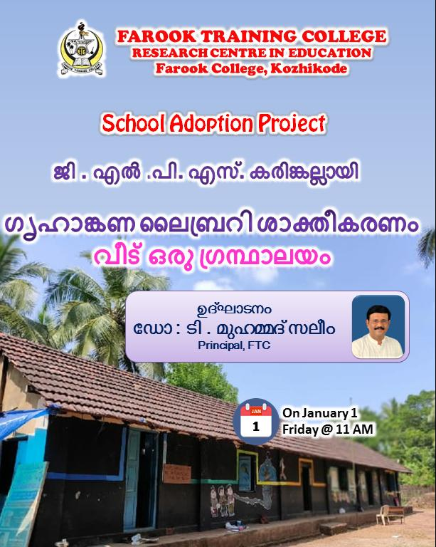
Report
Home Library Empowerment Project @ GLPS Karinkallai
1st January 2020

As part of the FarooK Training College School Adoption Project, GLP School Home Library Empowerment Program was launched at the school. Farook Training College Principal Dr.T. Muhammad Saleem inaugurated the project. The inauguration was held under the auspices of the Farook Training College School Adoption Project. School Headmaster in Charge Shri. Manoj Kumar, School Adoption Project Coordinator Mr. Faseel Ahammed, School P.T.A President Suchitra, Vice President Divyasree and Farook Training College teachers Dr. Niranjana KP and Mr. Rishad K also attended the programme.

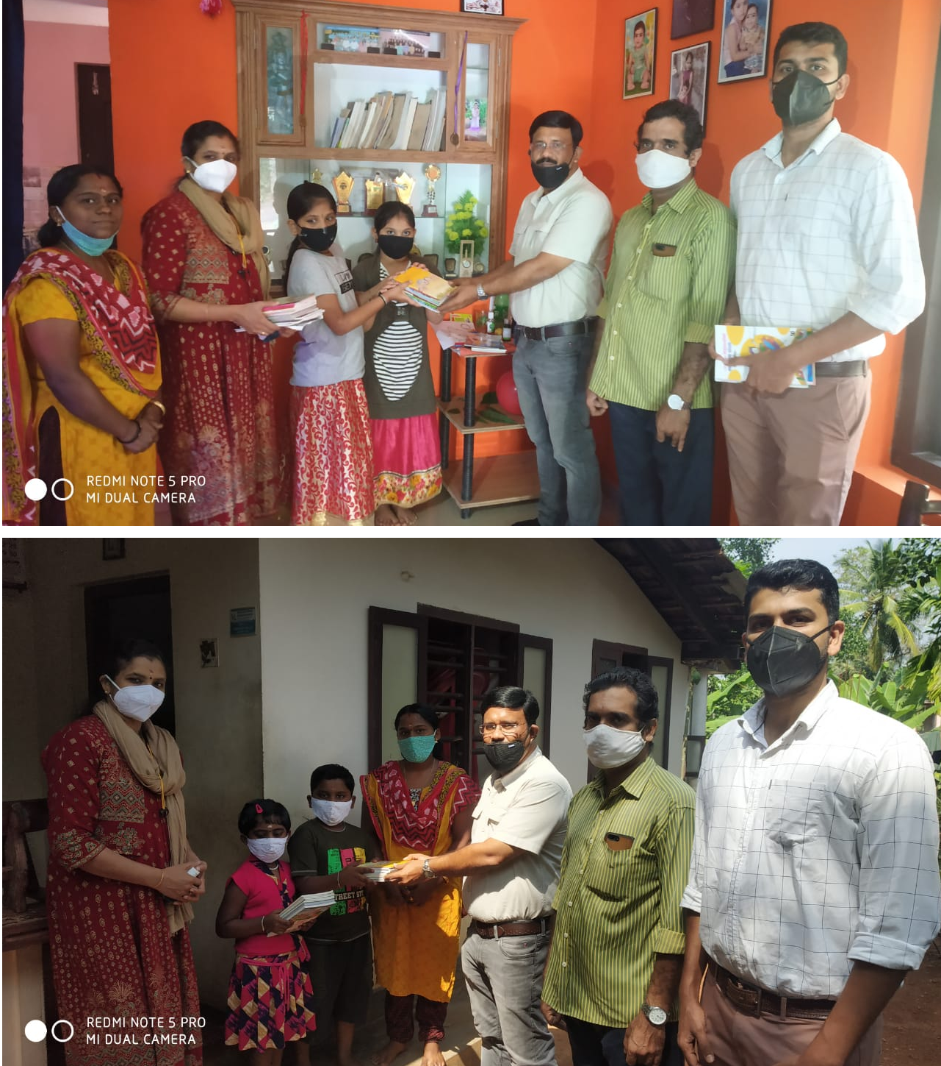
Gallery
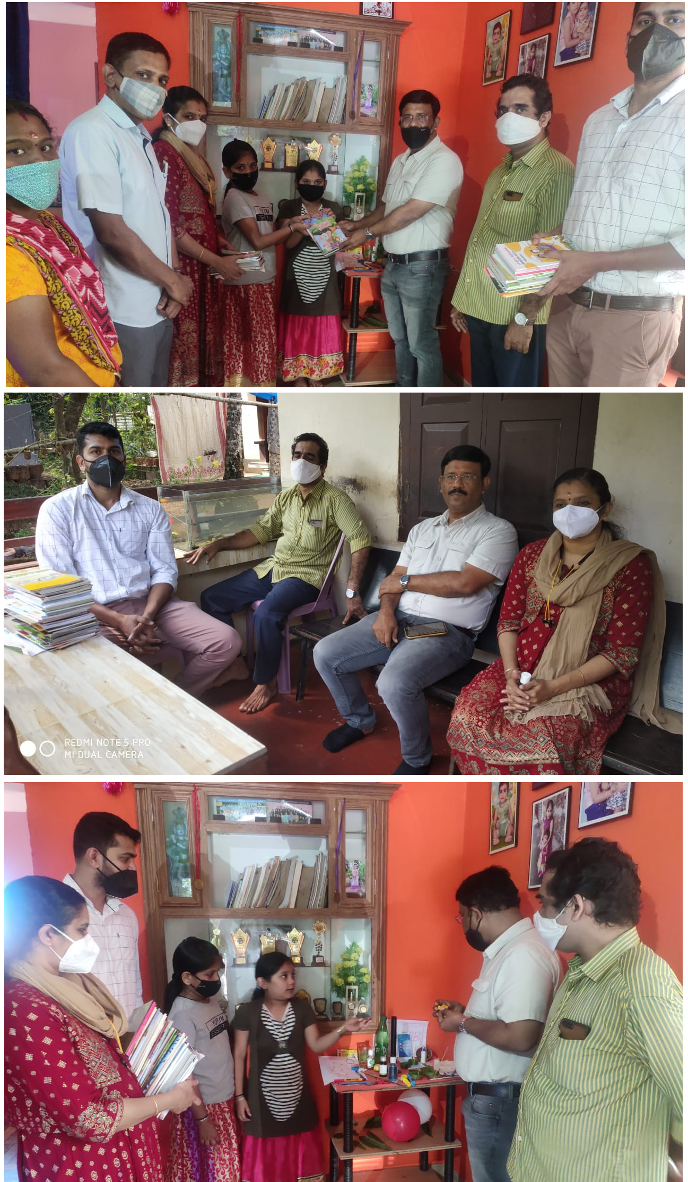
Appendix
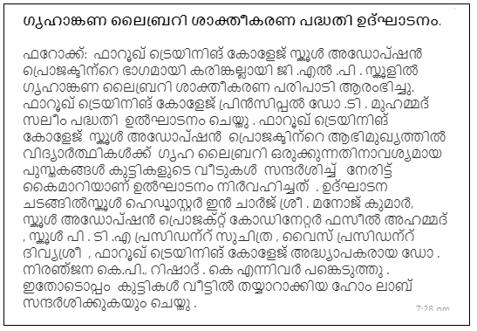

Prepared by Media Cell, FTC

