|Minutes of Meeting
Department Name : MEd. Association
Meeting date | time 6/20/2020 7:30 PM | Meeting location Online Meeting
Meeting called by Mr.Muhammed Fais KP  Type of meeting MEd Association  Facilitator Dr. Ummer Farooque TK  Note taker Mr.Muhammed Ismail  Timekeeper Ms. Shabeeha Shamsad | Attendees  Principal  Dr.Ummer Farooque TK  MEd Students

Meeting Agenda
Date 20/06/2020|Time allotted 1|From 7.30pm To 8.00 pm| Presenter Mr. Muhammed Fais KP

- The M. Ed students of Farook Training College decided to take up the T. V challenge to help out the students who lacked the facilities for online learning in the Lock down Covid 19 period

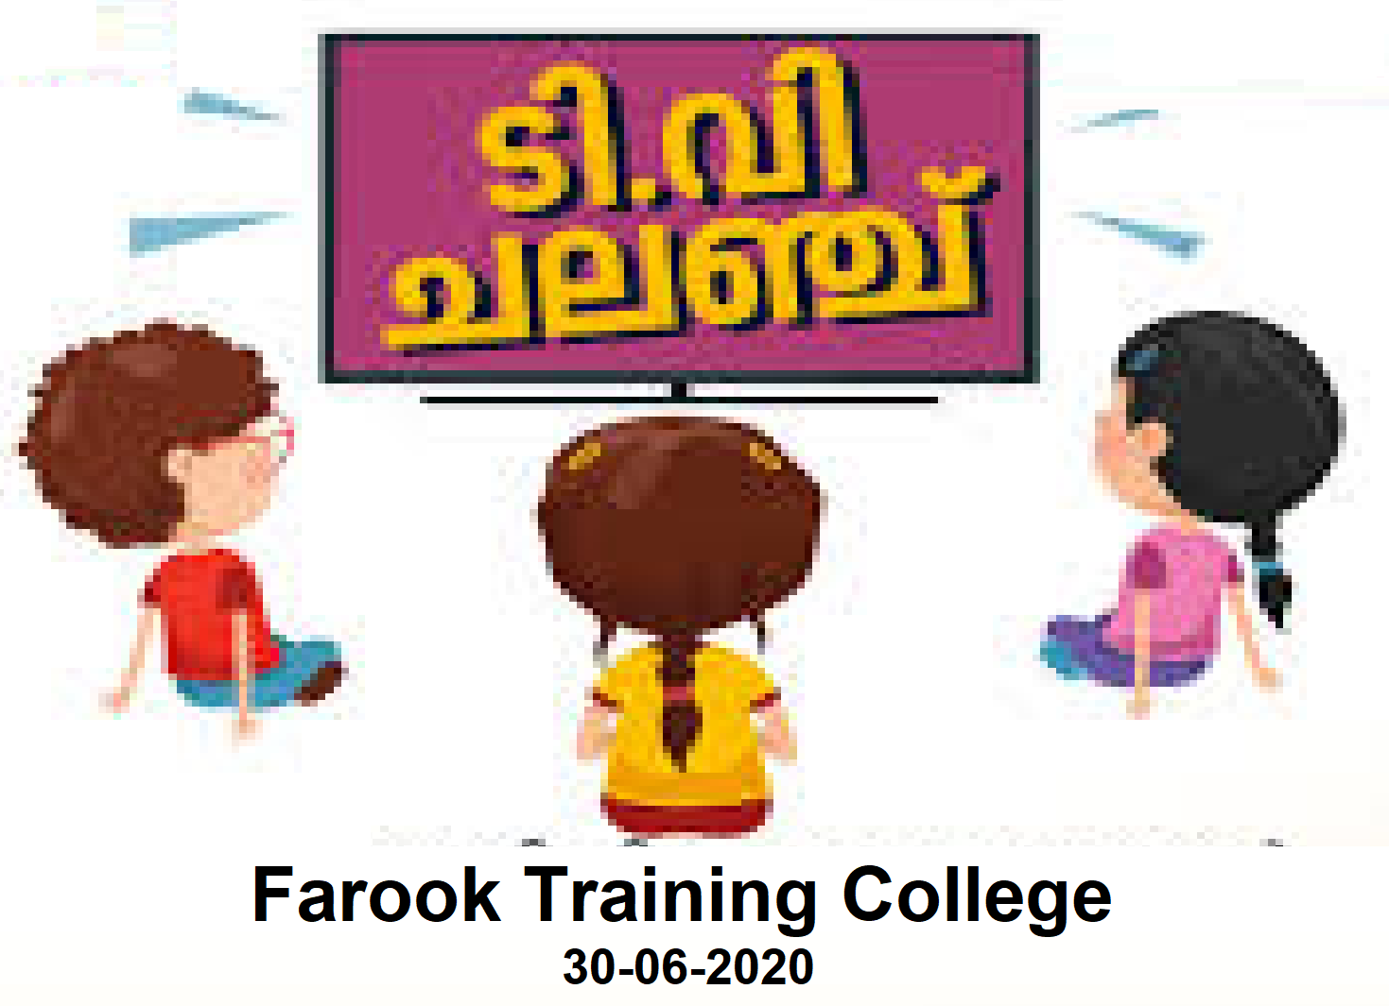
Report
Farook Training College lend a hand in the T. V challenge
30th June 2020
.

The M. Ed students of Farook Training College took up the T. V challenge to help out the students who lacked the facilities for online learning on 30/06/2020(Tuesday). The Principal of the college Dr. T. Mohamed Salim handed over the T.V to the students in the presence of M.Ed coordinator Dr. T.K Umer Farooque and Dr. Fathima Jaseena M.P.M and M.Ed class rep Shiji P.C

Gallery
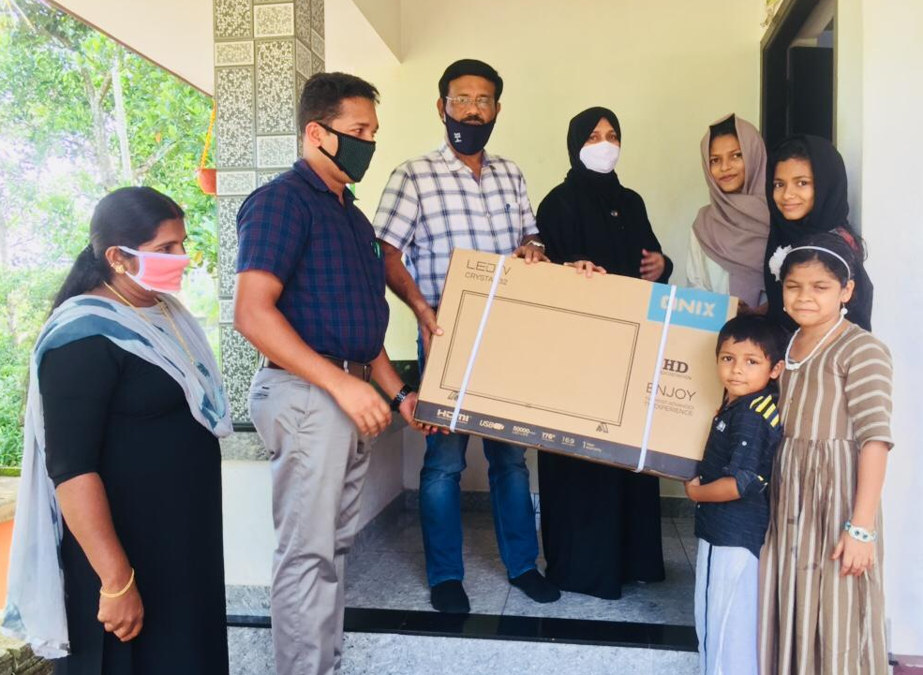
Gallery
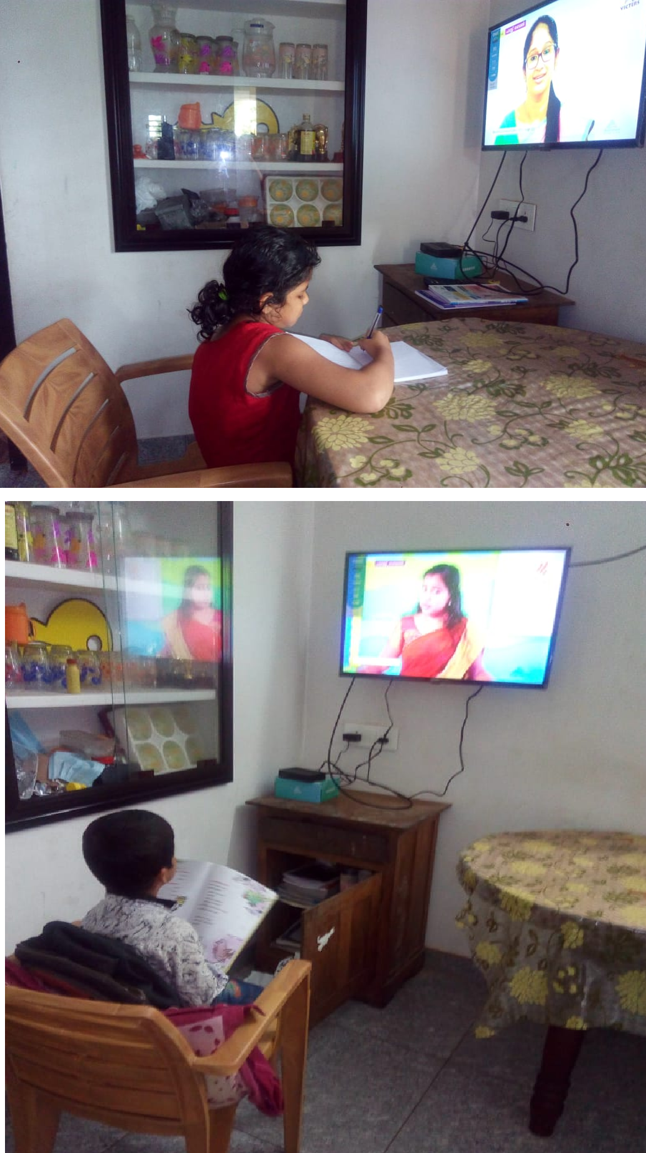
Appendix
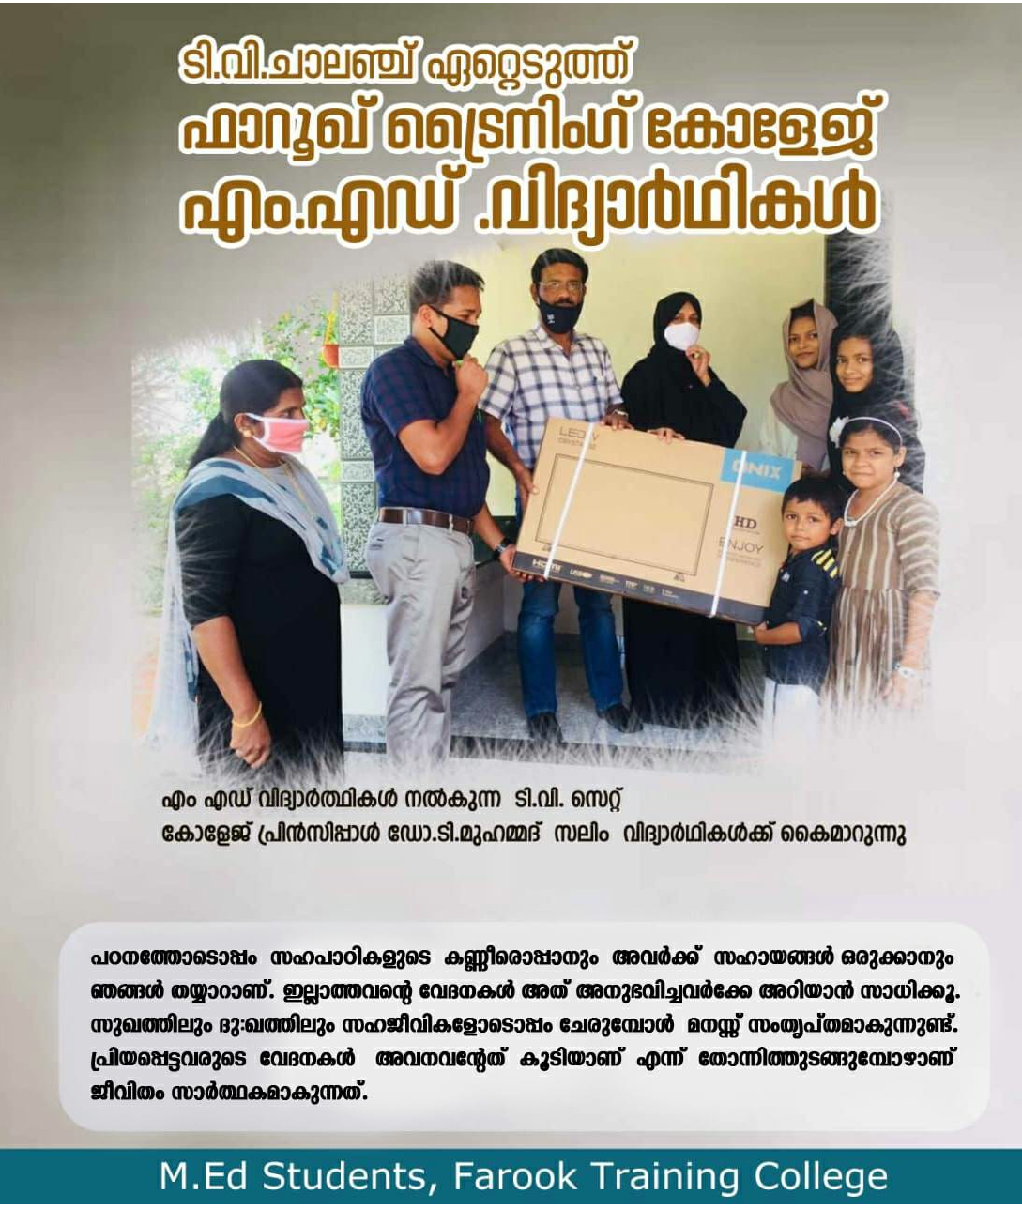
Prepared by Media Cell, FTC

