Union Meeting |Minutes of Meeting
Department Name : College Union
Meeting date | time 4/10/2020 3:00 PM | Meeting location Online
Meeting called by Dr. Aseel Abdul Wahid  Type of meeting Union Meeting  Facilitator Dr. K Vijayakumari  Note taker Mr. Vipin  Timekeeper Ms. Sayoojya | Attendees  Dr.T Muhammed Saleem  Dr. Aseel Abdul Wahid  Dr. Vijayakumari  All College Union Members

Meeting Agenda
  - Date 04/10/2020|Time allotted 1|From 3.00pm To 4 pm| Presenter Mr. Sreehari

- To conduct Habitat Photography Contest to identify the creativite talents among students in the Covid 19 Lockdown period.

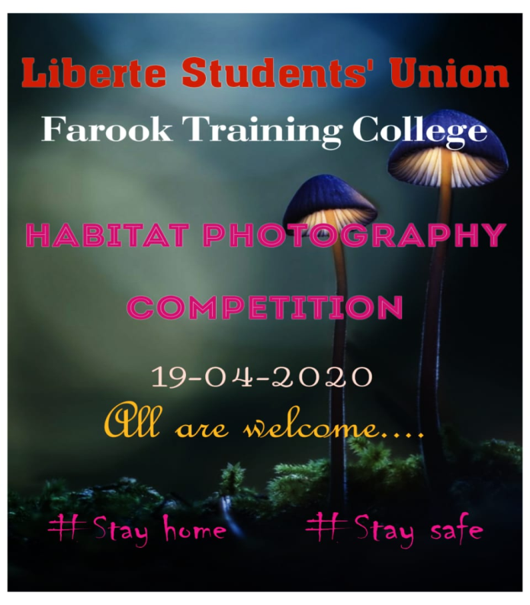
Report
Habitat Photography Contest
19th April 2020

To make lock down period creative Liberte students union of Farook training college has oraganiszed Habitat Photography contest on 19-04-2020 . There was a huge participation in the contest, not only college students but also people from outside college. The contest was titled with the motto ' only travelling is restricted not the creativity'. Photos of the size less than 8 MB taken by the students over a week were collected through whatsapp and winners were announced on 19- 04-2020.
First year BEd mathematics student Varsha won first place , Althaf of second year BEd mathematics won second place And Shahina of first year BEd physical science won third place in this contest. The contest was a grand success with great participation and All the creative clicks of contestants were displayed on union's official Facebook page.
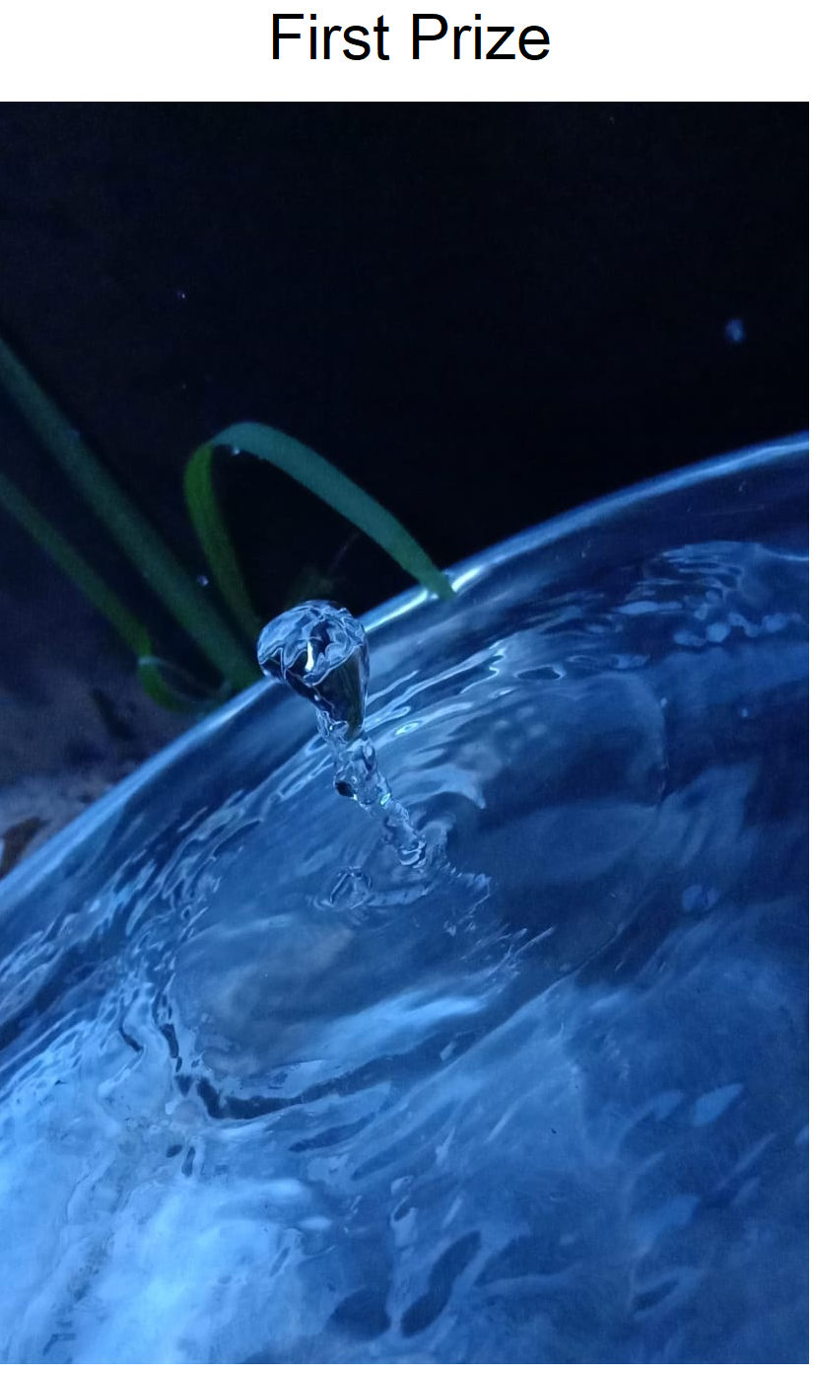
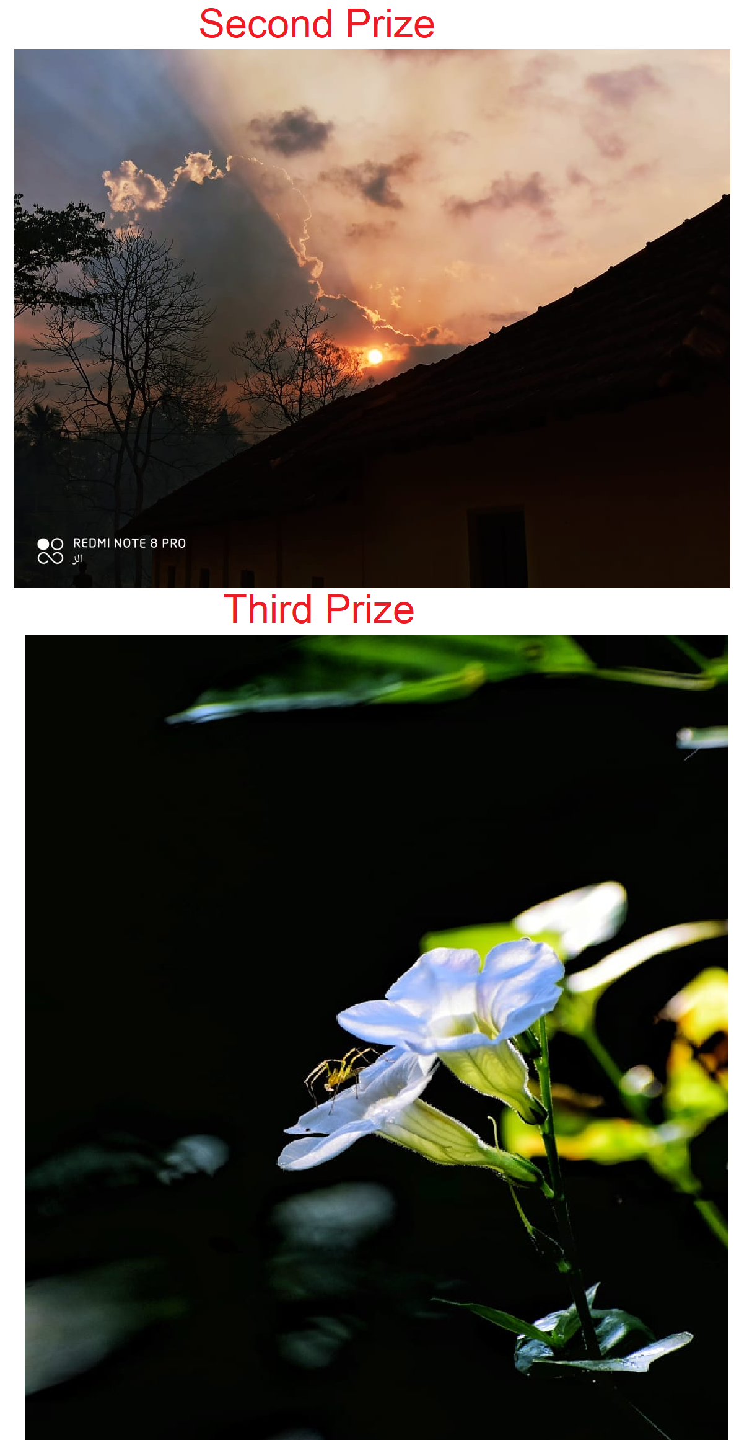
Gallery
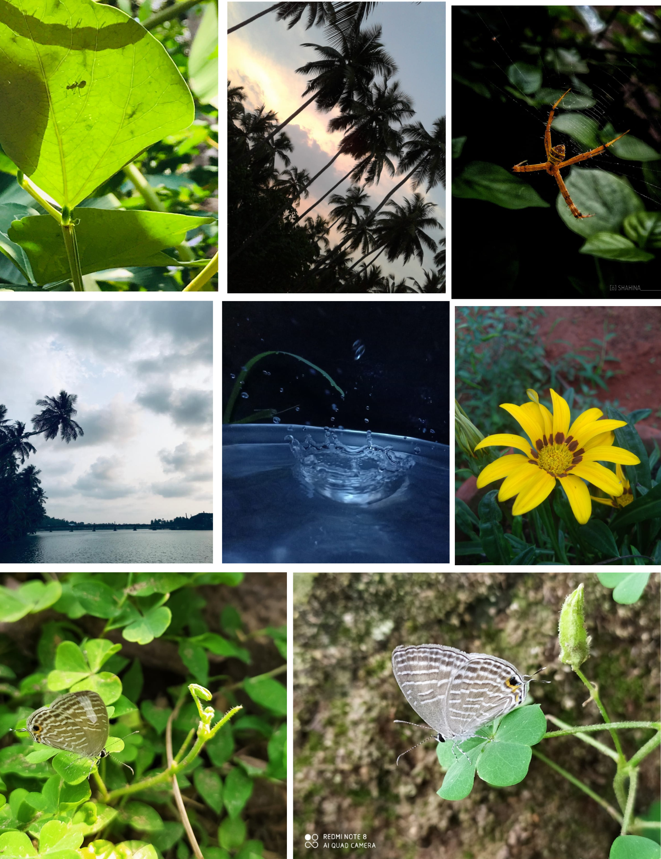
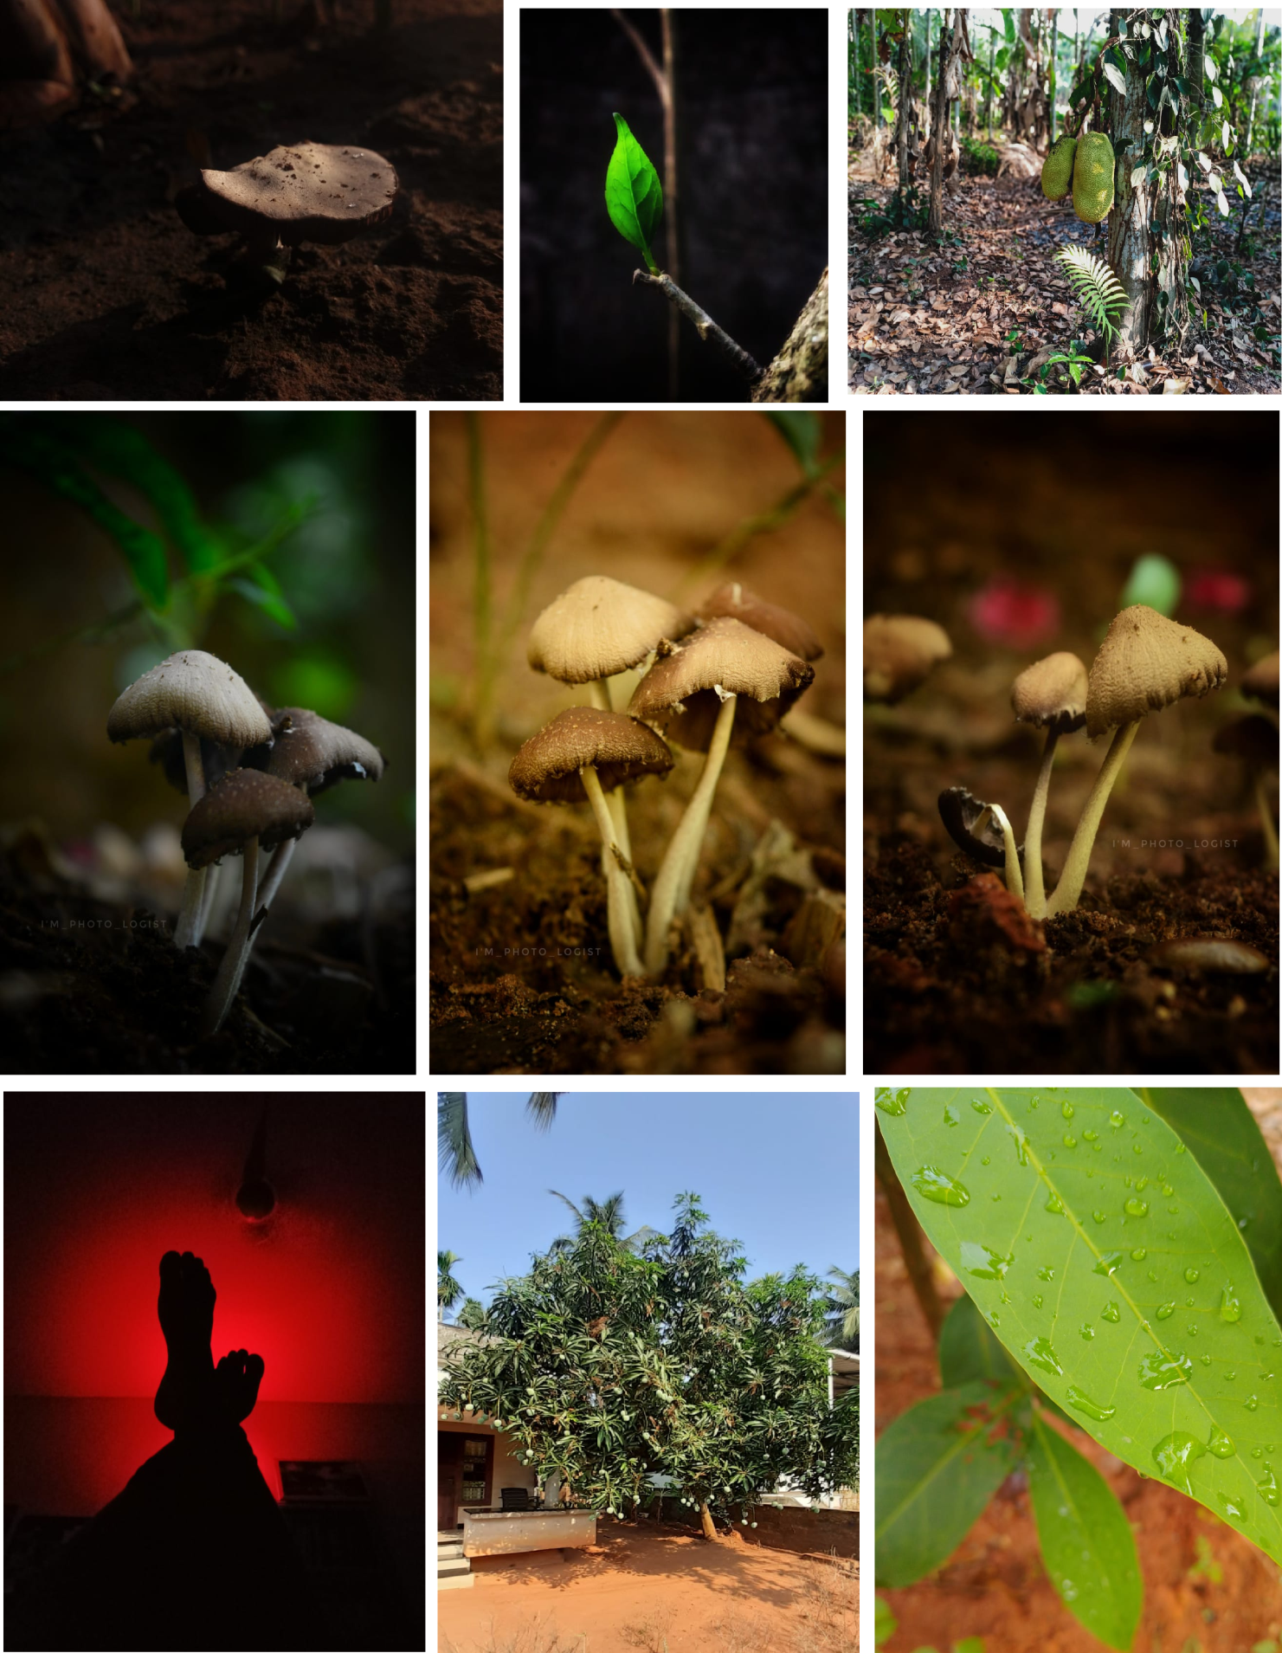
Appendices
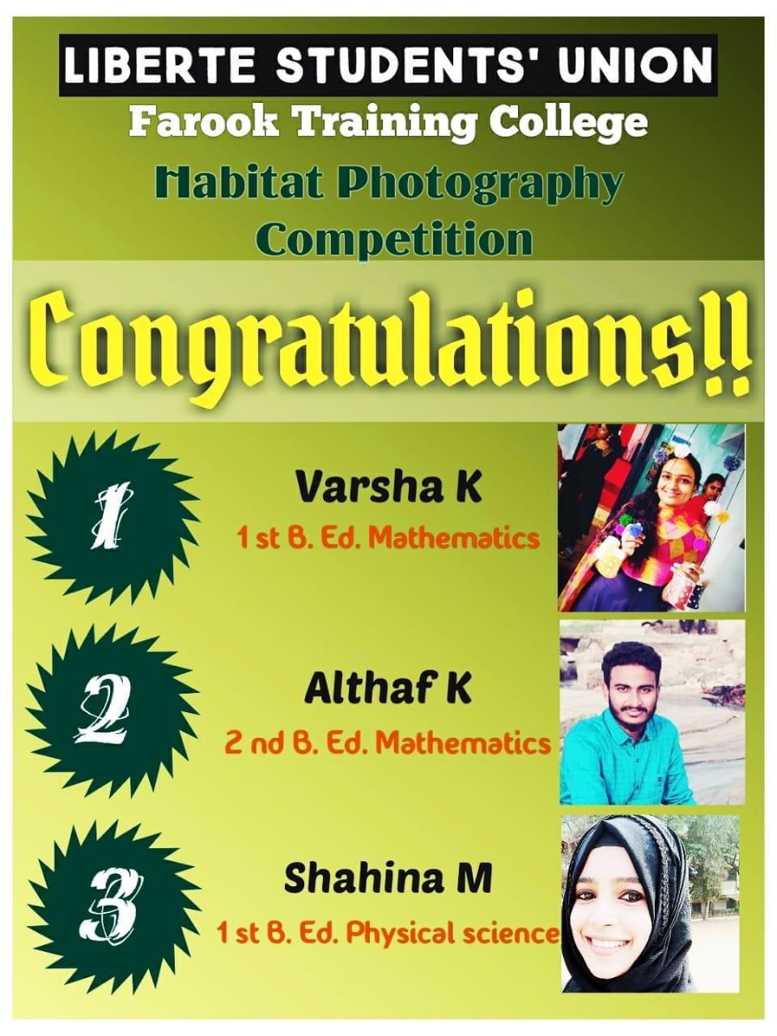
Prepared by Media Cell, FTC

