Union Meeting |Minutes of Meeting
Department Name : IQAC
Meeting date | time 10/6/2020 2:00 PM | Meeting location Online- G Meet
Meeting called by Dr. Manoj Praveen G  Type of meeting IQAC  Facilitator Dr. T Mohammed Saleem  Note taker Mr. Noufal C  Timekeeper DDr. Aseel Abdul Wahid | Attendees  Dr. Muhammed Saleem T  Dr. Manoj Praveeen G  Mr. Nufal C  Mr. Fasalul Abid CM  Mr. Muhammed Sareef K, Staff Secretary  IQAC Members

Meeting Agenda
  - Date 06/10/2020|Time allotted 1|From 2.00pm To 2.30 pm| Presenter Mr. Noufal C

- Farook Training College IQAC, OCLP, Gurudharshan and Finishing School are jointly organizing a Ten-day online enrichment session for candidates preparing for LPSA & UPSA examinations from October 10th to 20th .

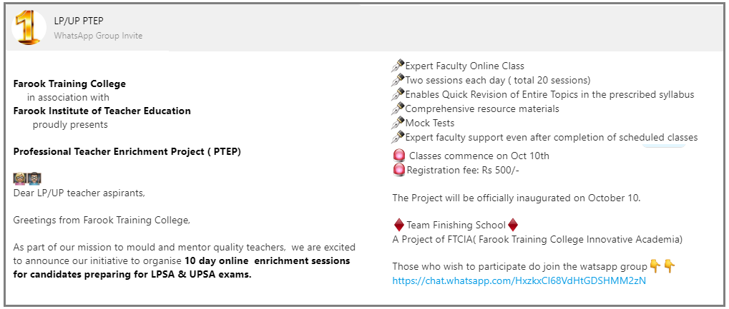
Report
Ten Days Online Enrichment Session for KTET Teacher Aspirants
7th – 18th December 2020

As part of our mission to empower prospective teachers and to equip our students to qualify KTET examination Prospective Teacher Empowerment Program, 10 days Online Enrichment sessions for KTET aspirants was organised by Farook Training College, Calicut from 07/12/20 to 18/12/20. The initiative commenced on 07/12/2020 with the Inauguration and general orientation by Dr T Muhammad Saleem, the principal, Farook Training College. Presidential talk was delivered by Mr Nowfal C, the project director.The college YouTube channel Gurudarsan live telecasted the Inaugural and valedictory Sessions. Classes were handled by eminent resource persons including Abdul Qadir, Faris , Nowfal C, Dr. Muhammed K V, Rajitha KV, Dr Afeef T, Dr TK Umer Farooque, Fasalu Abid, Dr Fathima Jaseena ,KM Shareef, Dr Jesa, Dr Hassan Koya, Dr Manoj Praveen, Dr Jouhar Munavvir, Irshana U, Rishad K, Dr Niranjana and Dr Vijayakumari on the various content areas covering Psychology, Pedagogy, English, Malayalam, Social Science, Physical Science Natural Science and Mathematics based on the syllabus prescribed for KTET category 3. Dr Anees Mohammed C, Mrs. Irshana Shahnaz U and Mr Faseel Ahmed coordinated various sessions.
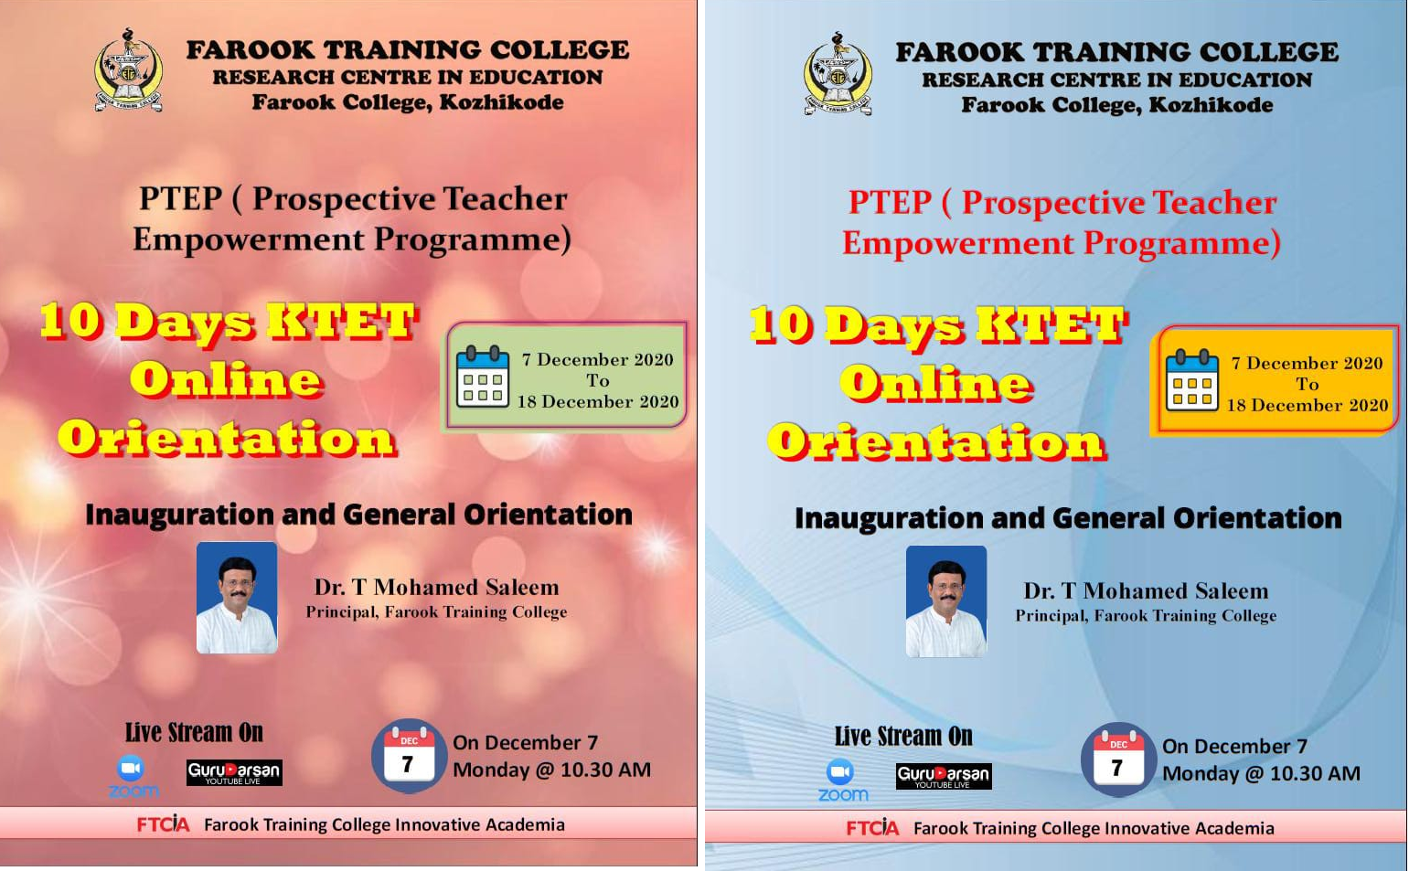
FAROOK TRAINING COLLEGE
10 Days KTET ONLINE ORIENTATION
7th to 18th December 2020

Schedule
NO | DATE | TOPIC | RESOURCE PERSON | TIME
1 | 07/12/20 | General Orientation & Inauguration | Dr T Mohamed Saleem  Principal, FTC | FN
2 | 07/12/20 | Teaching Aptitude-Part 1 | Dr Muhammed KV  MG University | AN
3 | 08/12/20 | Teaching Aptitude-Part 2 | Dr Muhammed KV  MG University | FN
4 | 08/12/20 | Teaching Aptitude-Part 3 | Dr Muhammed KV  MG University | AN
5 | 09/12/20 | Factors Affecting Learning and Creativity | Dr Afeef Tharavattath, FTC | FN
6 | 09/12/20 | Theories of learning | Mohammed Shareef, FTC | AN
7 | 10/12/20 | General English- Part 1 | Noufal C, FTC | FN
8 | 10/12/20 | Malayalam- Part 1 | Rajitha KV, FTC | AN
9 | 11/12/20 | Problems of adolescents and Developmental theories | Dr Umer Farooque TK, FTC | FN
10 | 11/12/20 | Children With Special Needs | Dr.Aseel Abdul Wahid | AN
11 | 12/12/20 | Malayalam- Part 2 | Rajitha KV, FTC | FN
12 | 12/12/20 | General English- Part 2 | Muhammed Farish | AN
13 | 15/12/20 | Growth and Development | Fasalul Abid CM, FTC | FN
14 | 15/12/20 | General English- Part 3 | Dr Jesa M, FTC | AN
15 | 16/12/20 | Introduction to Learning | Dr Fathima Jaseena, FTC | FN
16 | 16/12/20 | General Malayalm Part 3 | Rajitha KV, FTC | AN
17 | 17/12/20 | Evaluation from pedagogy of all the subjects | Dr Niranjana KP, FTC | FN
18 | 17/12/20 | Pedagogy and Methodology of English, Malayalam, Mathematics, NS, PS & SS | Dr Vijayakumari, Dr Jesa M, Dr Manoj Praveen G, Dr Hassan Koya, Dr Afeef , Dr Jouhar Munavvir, Rishad, Irshana, Nowfal , Shareef , Rajitha, Fasalul Abid | AN
19 | 18/12/20 | Pedagogy and Methodology of English, Malayalam, Mathematics, NS, PS & SS | Dr Vijayakumari, Dr Jesa M, Dr Manoj Praveen G, Dr Hassan Koya, Dr Afeef , Dr Jouhar Munavvir, Rishad, Irshana, Nowfal , Shareef , Rajitha, Fasalul Abid | FN
20 | 18/12/20 | ValedictorySession

Time:
FN Session: 10.30 AM to 12.00 Noon
AN Session: 2.00 PM to 3.30 PM
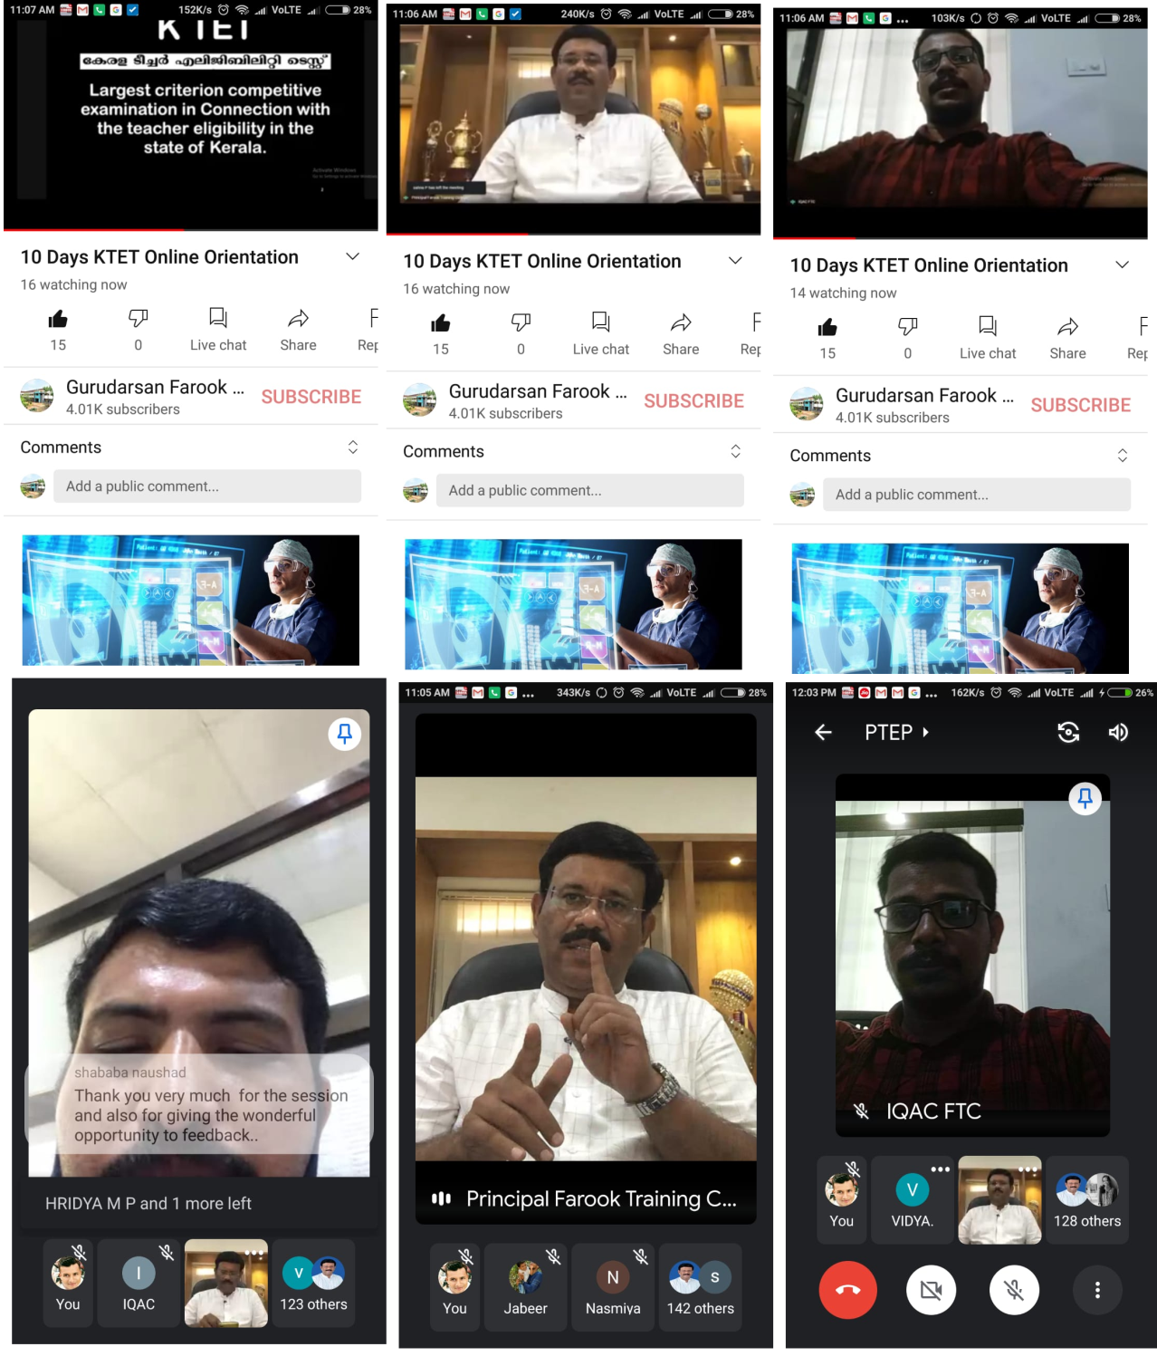

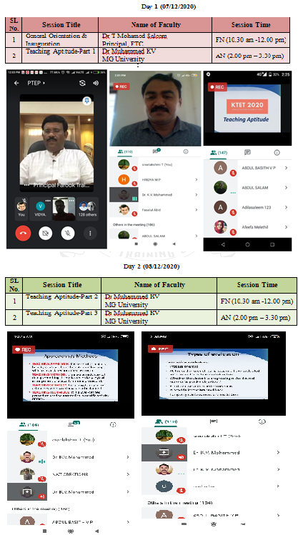
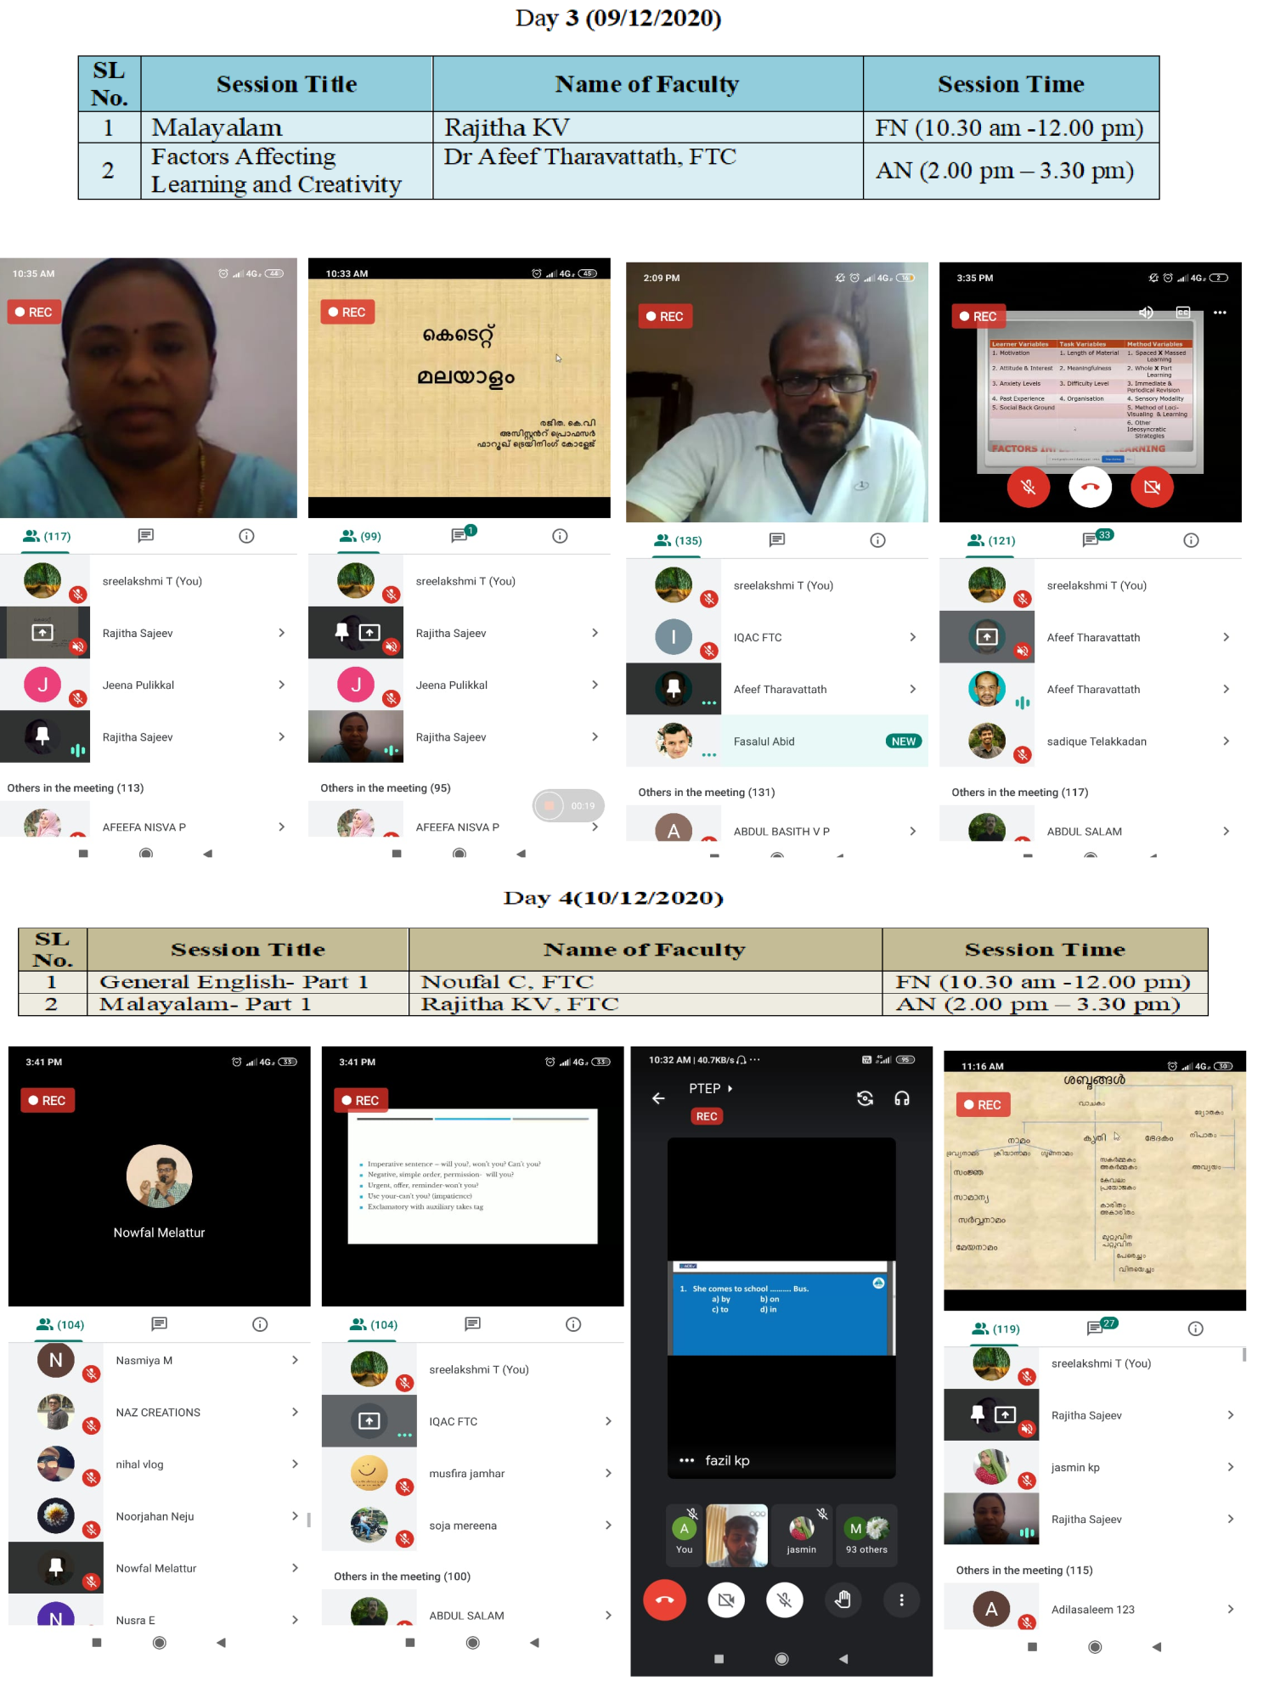
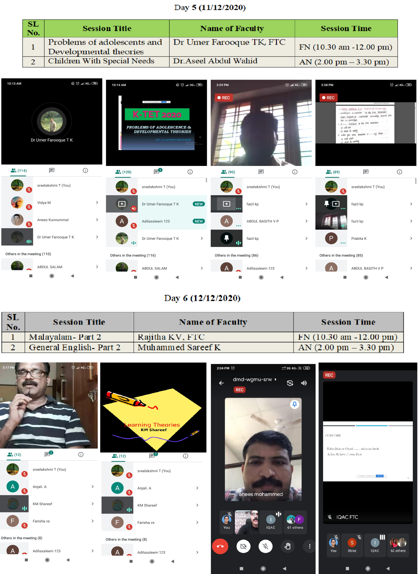

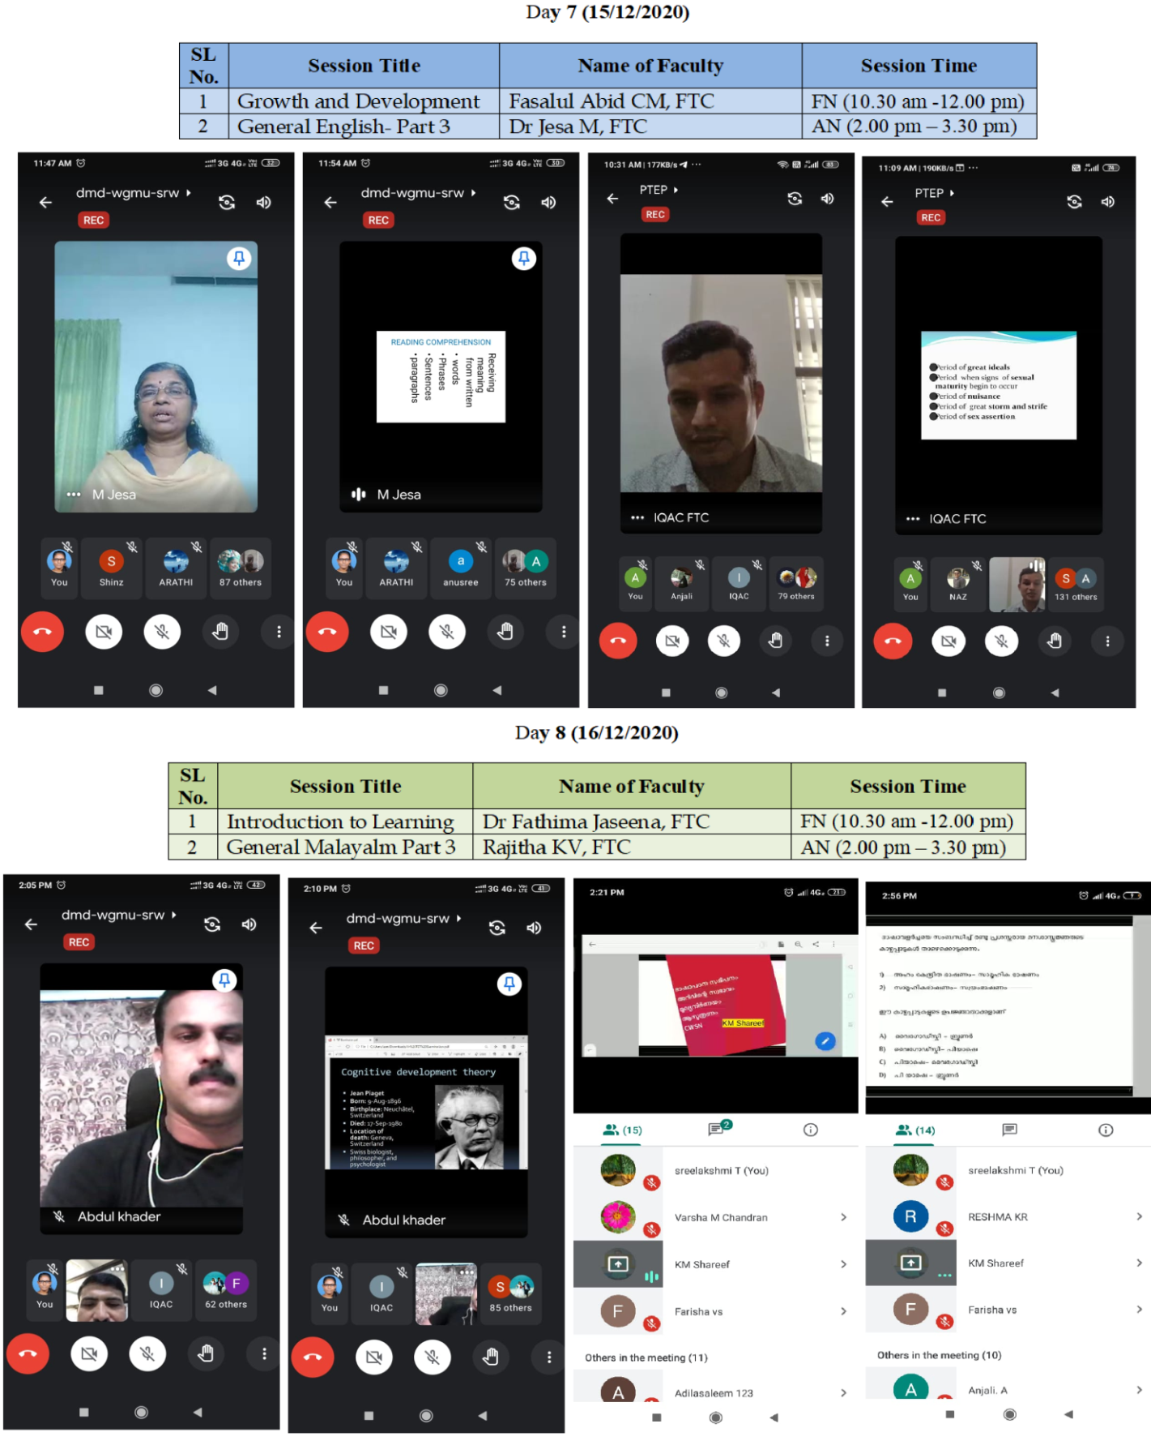
Prepared by Media Cell, FTC

Day 9 (17/12/2020)
SL No. | Session Title | Name of Faculty | Session Time
1 | Evaluation from pedagogy of all the subjects | Dr Niranjana KP, FTC | FN (10.30 am -12.00 pm)
2 | Pedagogy and Methodology of English, Malayalam, Mathematics, NS, PS & SS | Dr Vijayakumari, Dr Jesa M, Dr Manoj Praveen G, Dr Hassan Koya, Dr Afeef , Dr Jouhar Munavvir, Rishad, Irshana, Nowfal , Shareef , Rajitha, Fasalul Abid | AN (2.00 pm – 3.30 pm)

Day 10 (18/12/2020)
SL No. | Session Title | Name of Faculty | Session Time
1 | Pedagogy and Methodology of English, Malayalam, Mathematics, NS, PS & SS | Dr Vijayakumari, Dr Jesa M, Dr Manoj Praveen G, Dr Hassan Koya, Dr Afeef , Dr Jouhar Munavvir, Rishad, Irshana, Nowfal , Shareef , Rajitha, Fasalul Abid | FN (10.30 am -12.00 pm)
2 | Valedictory |  | AN (2.00 pm – 3.30 pm)

Appendix

9544780218 sruthy
9847498442 nusaibath
912.5
Prepared by Media Cell, FTC

