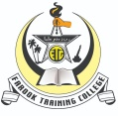 **|Minutes of Meeting**

**Department Name : College Union**

**Report**

**Inter Collegiate Gandhi Quiz Competition**

24th January 2021

The Inter-Collegiate Gandhi Quiz on "Gandhiji's Life, Vision and Time" was held on January 24 in the Chair for Gandhian Studies and Research, University of Calicut. 66 teams competed in the competition which was held at Tagore Niketan on the University campus. Amruta P Bhaskar and Sreelal K.V, first year M.Ed students of Farook Training College, competed in the final round (Top Ten Round) and placed sixth. Won Cash Award and Certificates.

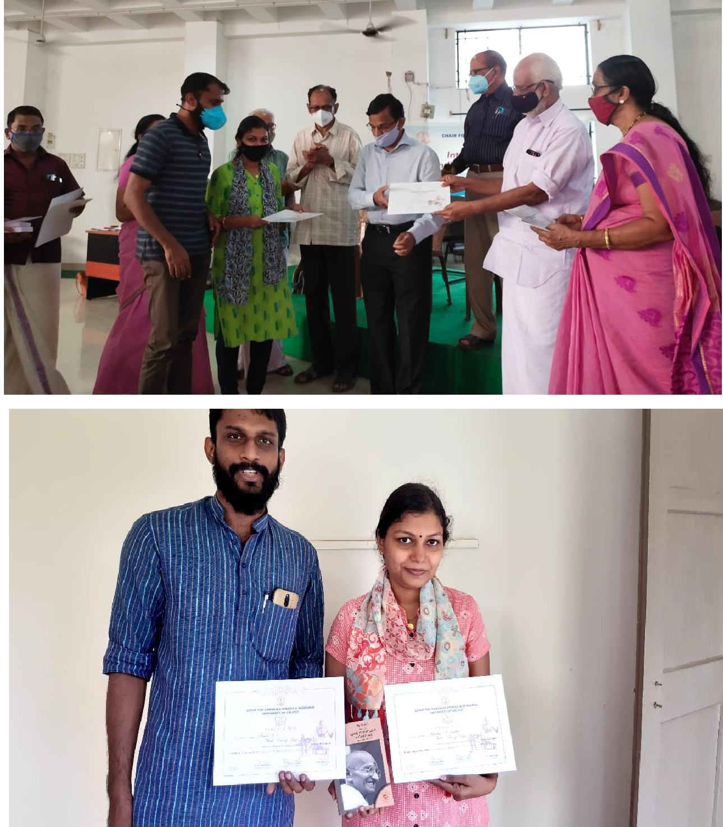

**Gallery**

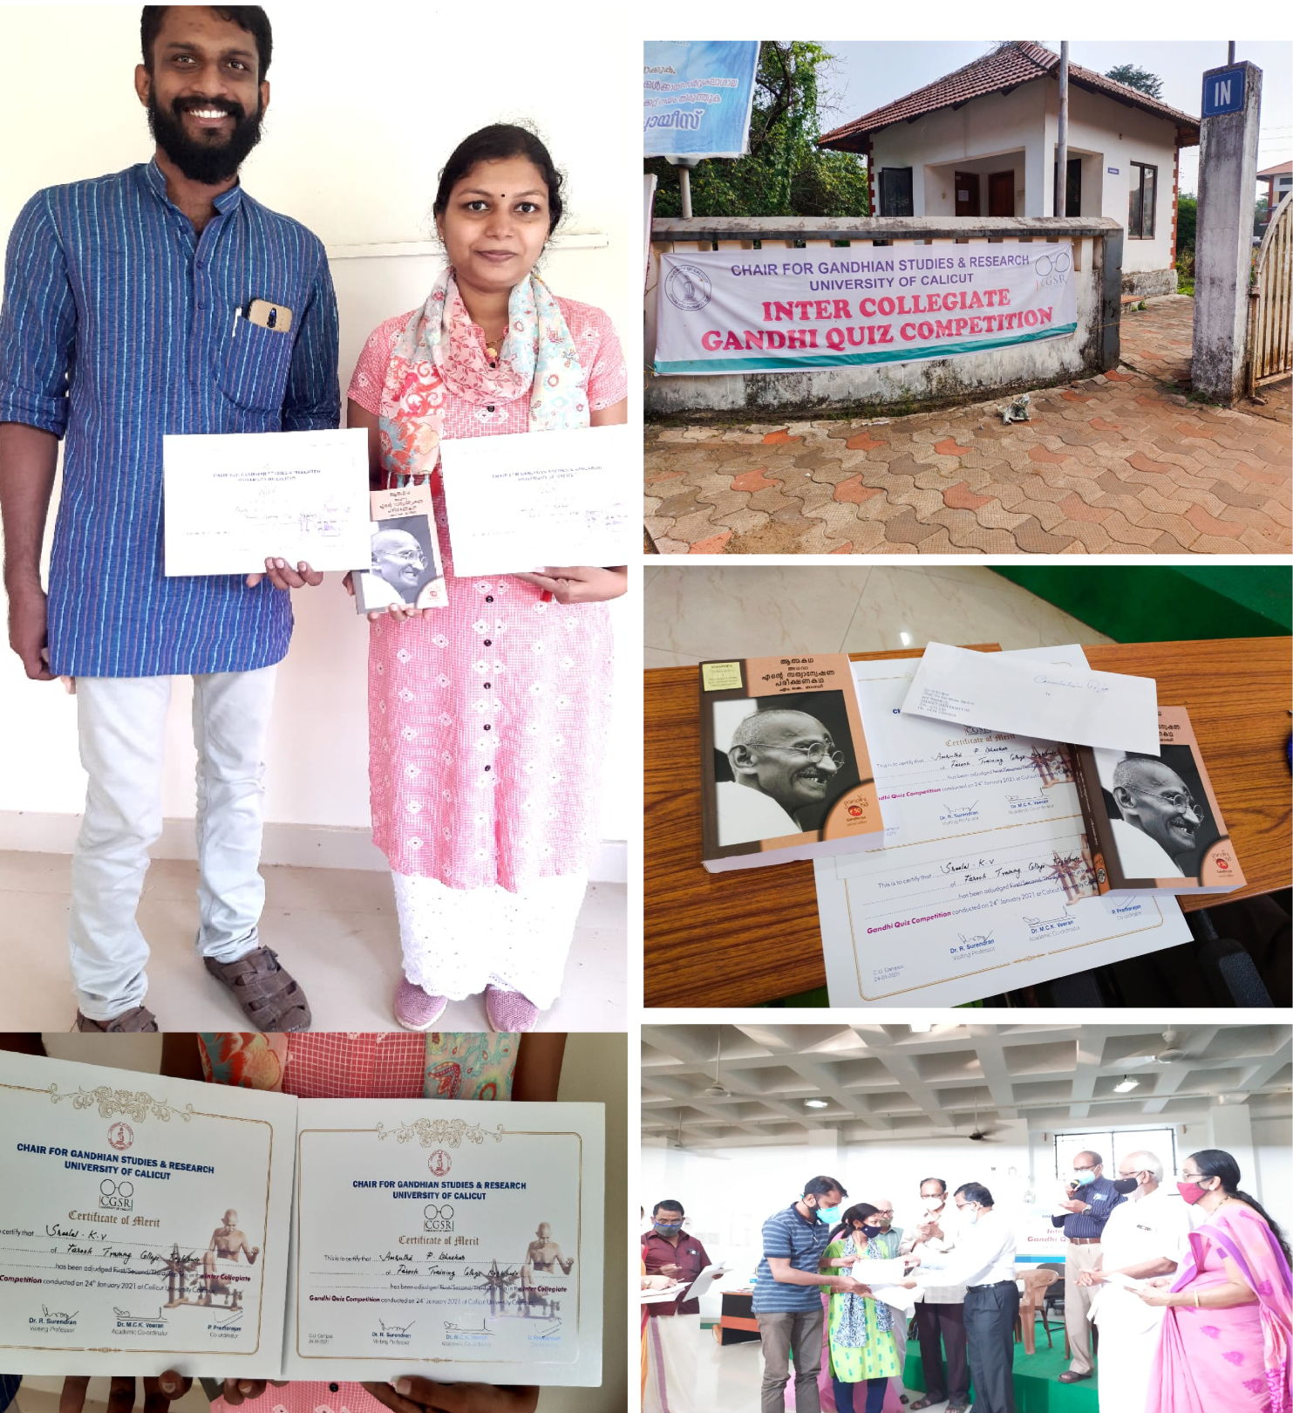

***Prepared by Media Cell, FTC***