|Minutes of Meeting
Department Name : FTCIA DPLP & IQAC
Meeting date | time 5/1/2020 7:00 PM | Meeting location Online
Meeting called by Dr. Aseel Abdul Wahid  Type of meeting FTCIA DPLP & IQAC  Facilitator Dr Mohammed Saleem T  Note taker Dr. Manoj Praveen G  Timekeeper Ms. Irshana Shahnaz U | Attendees  Dr. T Mohammed Saleem, Principal  Dr.Aseel Abdul Wahid, Program Administrator  Dr. Manoj Praveen G, IQAC Director  Mr. Muhammed Sareef K, Course Coordinator  Ms. Irshana Shahanaz U, Course Coordinator  Mr. Fasalul ABid CM, Course Coordinator

Meeting Agenda
  - Date 1/05/2020|Time allotted 1|From 07.00 pm To 9:00 pm| Presenter Dr.Aseel Abdul Wahid

- To conduct Free MOOC Coursera Programme to all the learners who are above the age of 12 under the sponsorship of FAROOK TRAINING COLLEGE, Calicut, named Digital Public Learning Platform (DPLP- Coursera) during the Covid Pandemic period from 12th May 2020 to 1st December 2020.

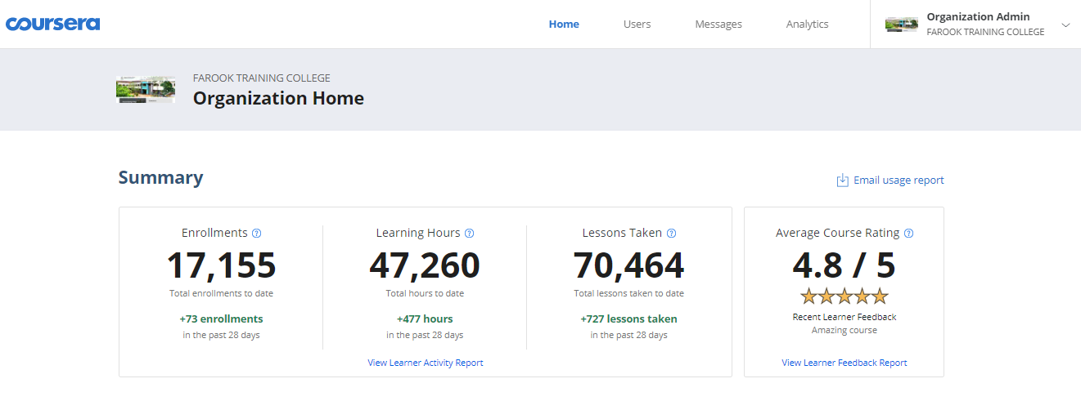
Report
FTCIA DPLP- Coursera (Digital Public Learning Platform)
12th May 2020 – 1st December 2020

Online learning platform gained new momentum due to the lockdown scenario all over the world. Massive online open learning facilities are widely utilised by not only academia but ordinary people also. In this context under Farook Training College Innovative Academia (FTCIA) explored the scope of massive learning and the task assigned to one of our team consisting of Dr. Aseel Abdul Wahid, Course Administrator, Mr. Mohamed Shareef, Mrs. Irshana Shahnaz and Mr.Fasalul Abid, Course Coordinators. After their systematic discussion and dedicated work, FTC successfully affiliated with “Coursera,” free of cost. Hence after the discussion, the expert group finalised the project title as: FTCIA DPLP (Digital Public Learning Platform)
Once again the wonderful combination of expertises blended together for FTC resulted in another achievement. Now, the DPLP platform has nearly 3911 learners across the globe led by 20 Wattsapp groups under the administration of the FTC team. Learners have benefited from this by having completed nearly 20000 courses from International Universities. The program is available for learners till December 1. Director of the Project is Dr. T.Mohammed Saleem, Principal, FTC.
With much pleasure, we would like to express our appreciation to the FTCIA DPLP team for their commendable work in initiating such a challenging project on May 12, 2020. The platform which began with 500 online learners has today nearly 4896 learners coming from a spectrum of backgrounds. We are blessed that Farook Training College has through this platform been once again able to fulfill its mission and vision. Our learners across the globe has completed 17155 world class courses, 47260 instructional hours from International Universities which is worth Rs 8,57,75,000 (Eight Crores, Fifty Seven Lakhs Seventy Five Thousand) approximately.
The responses received from our learners as text messages and voice noted indicates their joy as though of a fulfillment of a dream and an effective utilization the lockdown. Learners have successfully been able to complete diverse courses in perfect match with their needs and interests. This has been made possible only through the sheer 24×7 service of our dedicated staffs .

Video 1: https://youtu.be/lV8OjvnpdZU (Introduction to MOOC courses- Coursera)
Video 2: https://youtu.be/NSdjBBElxPw (Step by sstep procedure to join for Course, after receiving the invitation mail from Coursera)
Video 3: https://youtu.be/ohR6D60wsYA (Major doubts clearing videos like How do I verify my account? Not able to see any listing in the course catalogue? Not able to see the tab 'enrol for free?' How many courses I can do? What does 'Sponsored by Farook Training College Course mean'? Not able to see certificate even after completion of the course? Why does this 'Buy Certificate' come even after I did the course sponsored by Farook Training College?
Usage Summary
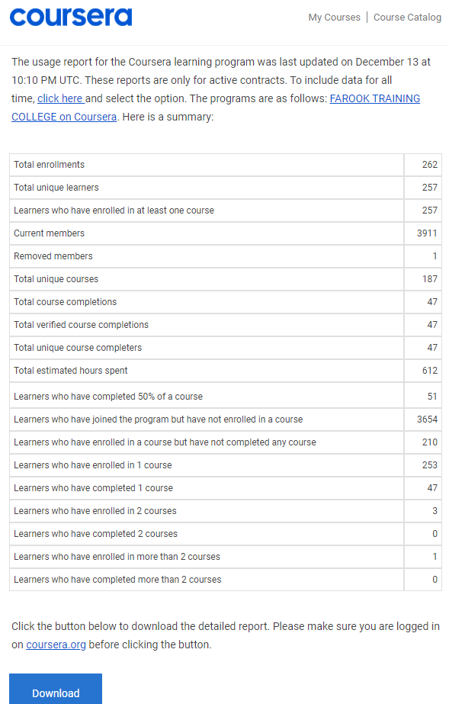

Orientation Programme on ‘ New NAAC Accreditation- Methodology and Procedures’
17th January 2020

Gallery
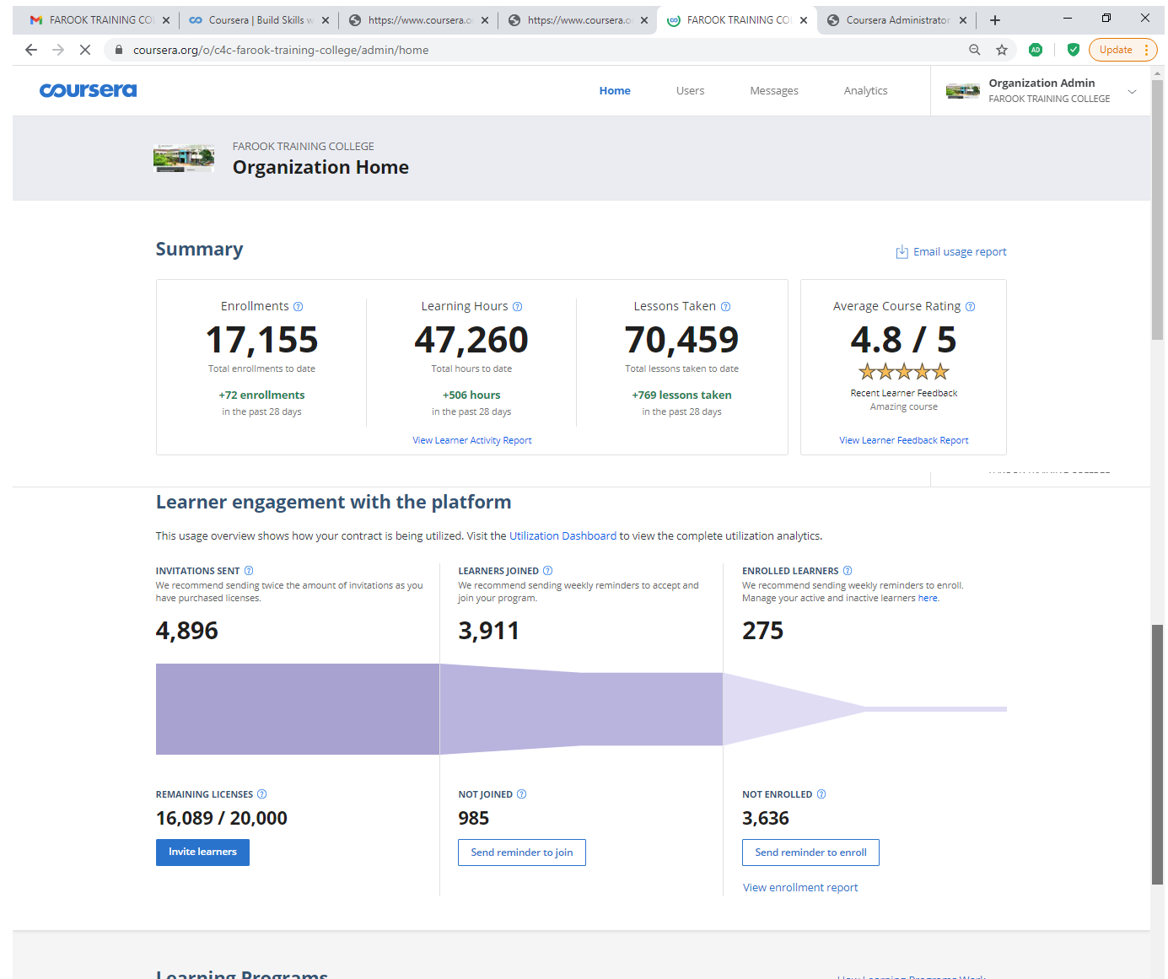

Analytics
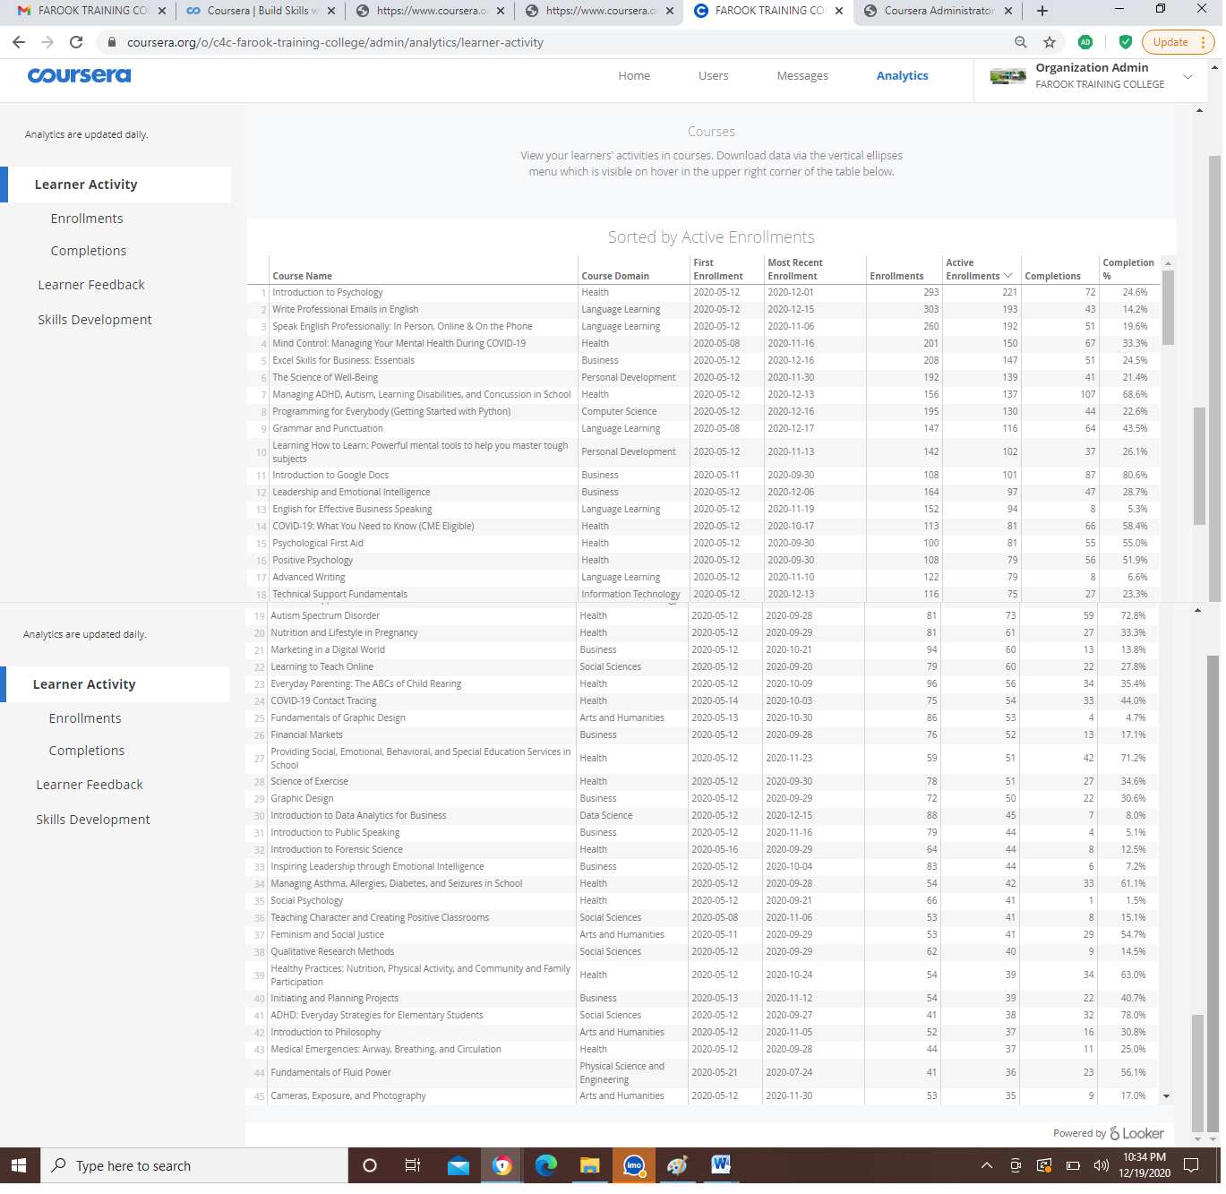
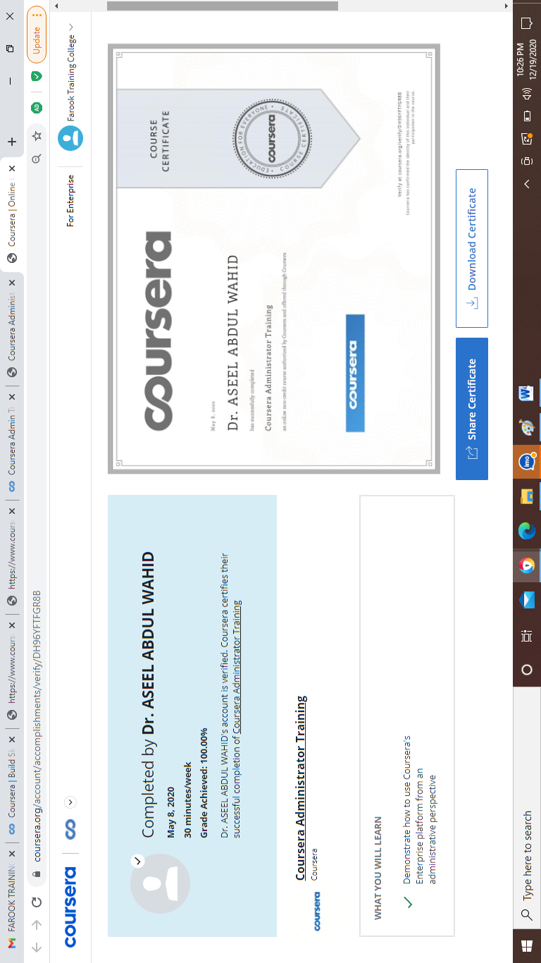

Appendix
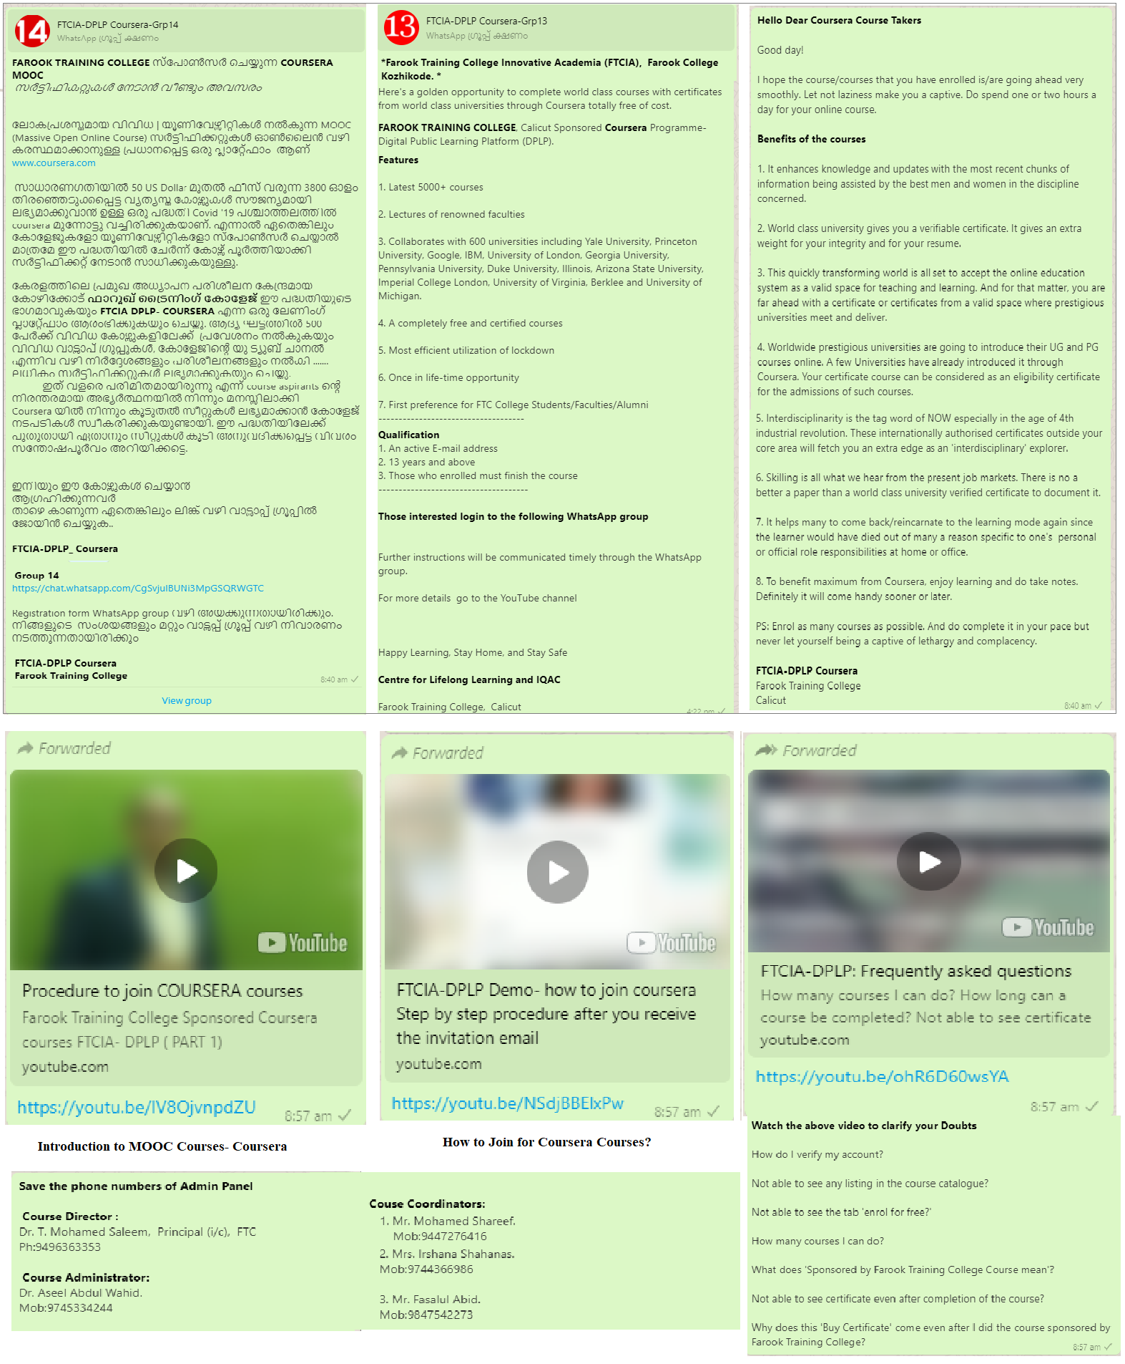
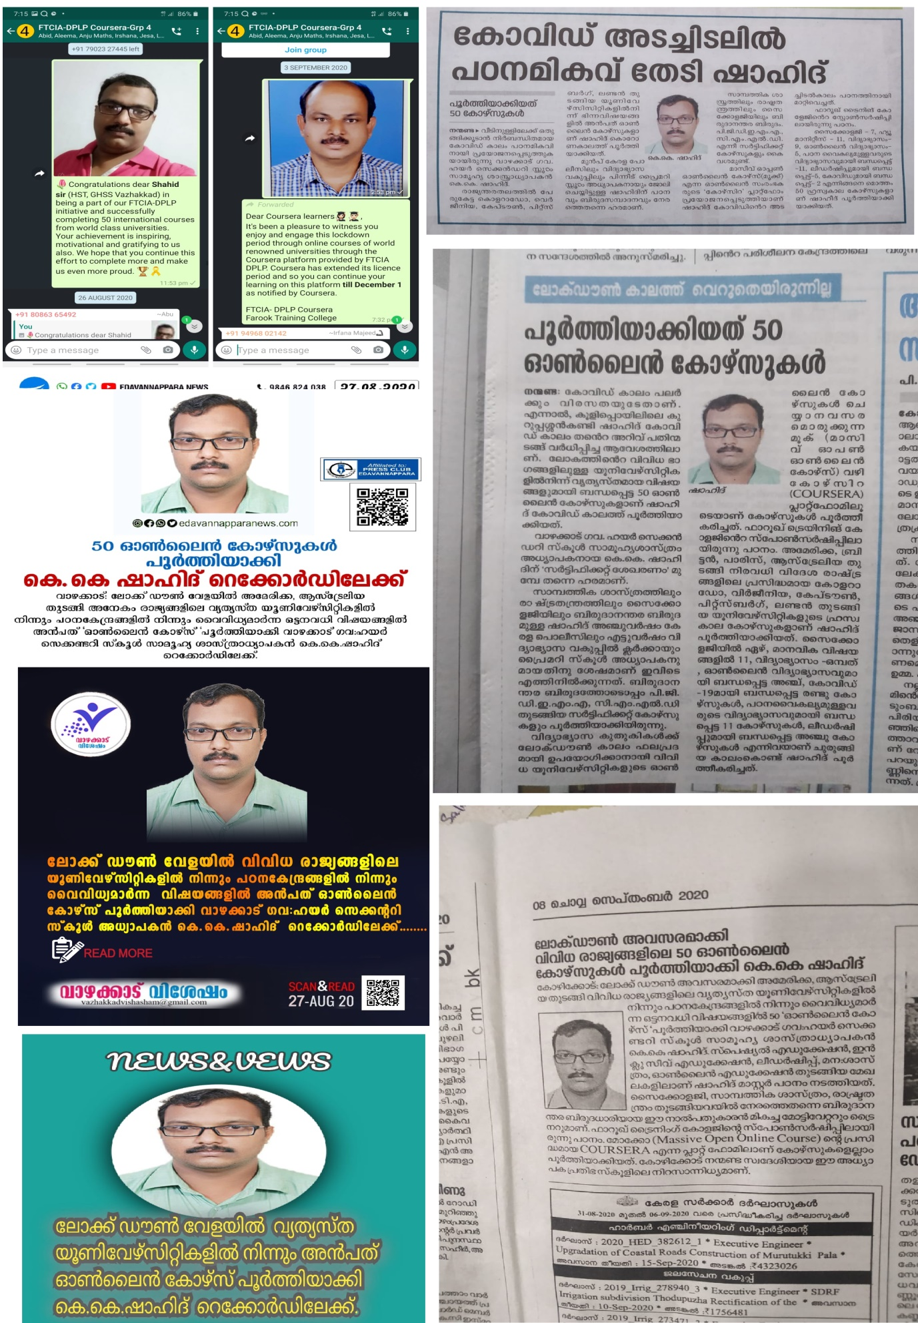
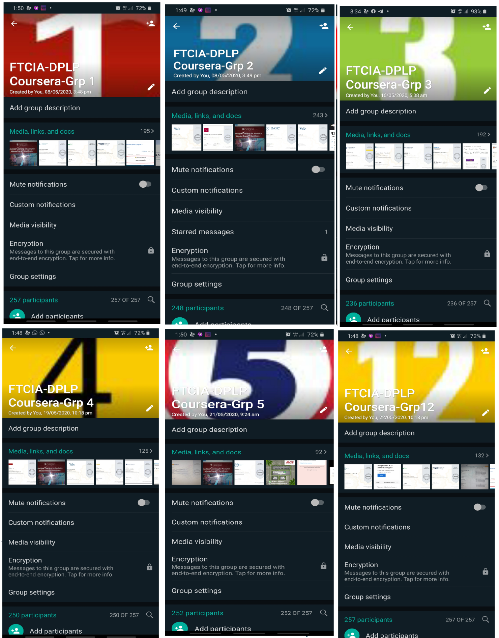
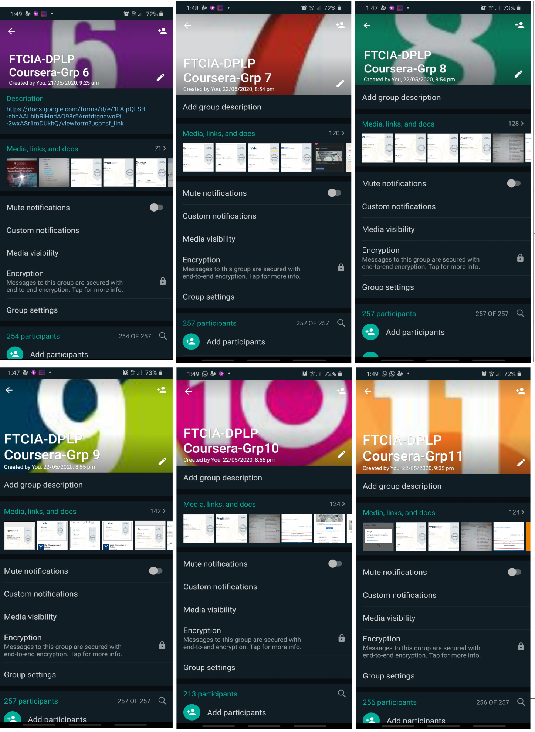
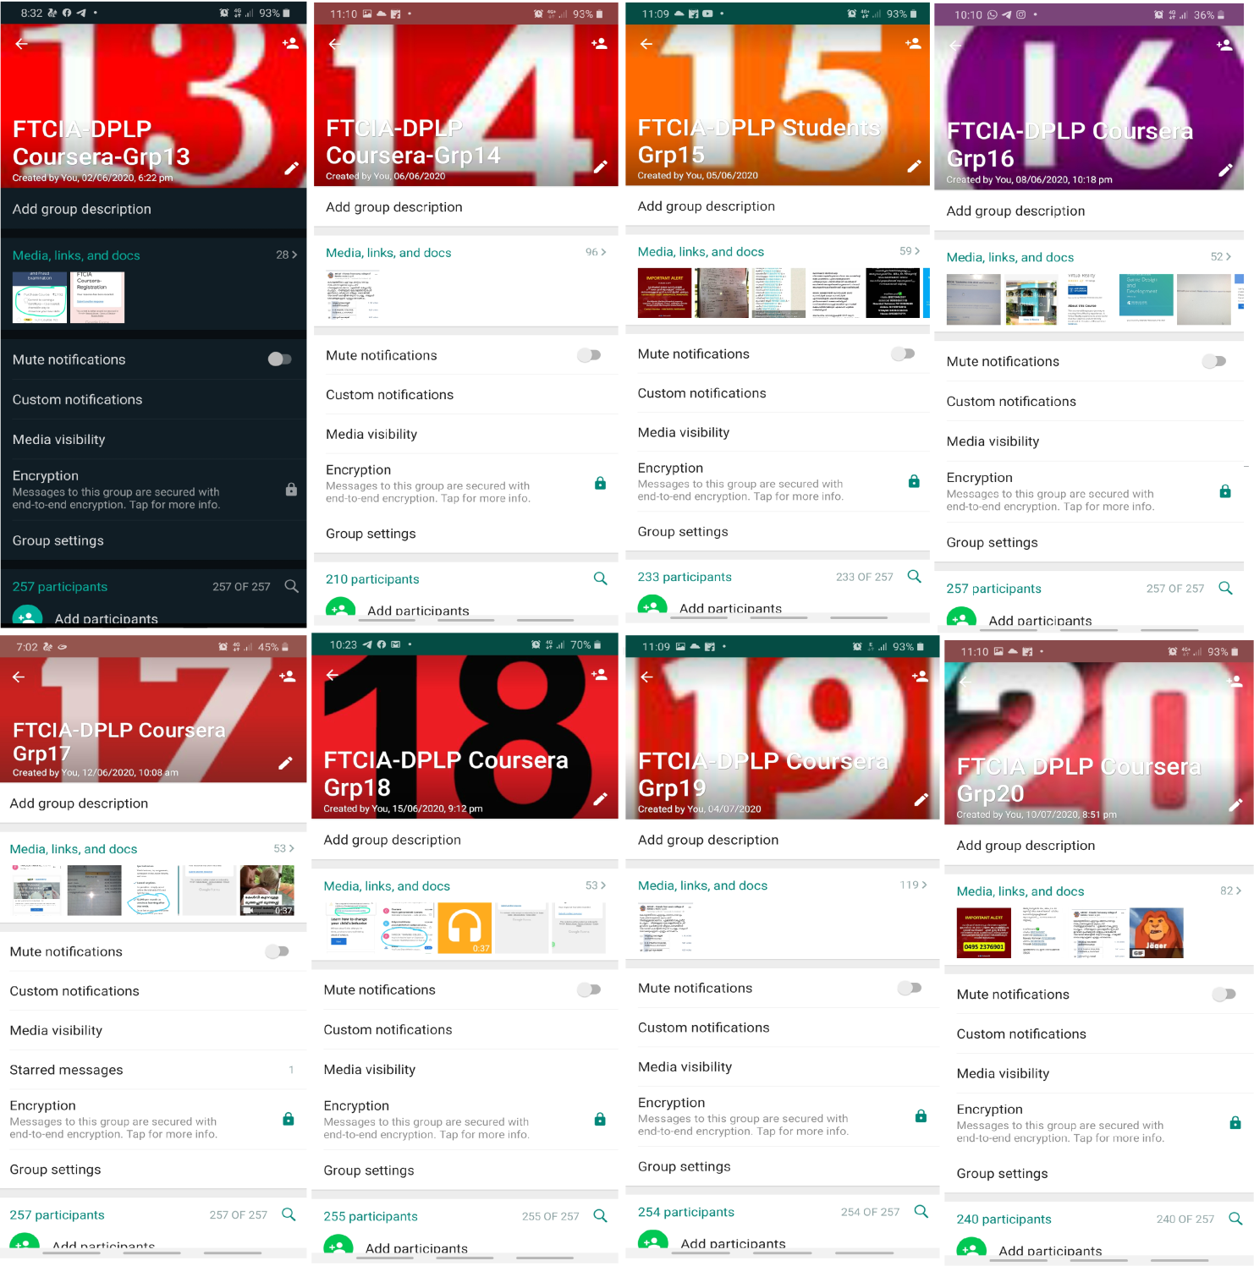

Prepared by Media Cell, FTC

