|Minutes of Meeting
Department Name : IQAC & Student Union
Meeting date | time 5/2/2020 7:00 PM | Meeting location Online
Meeting called by Principal  Type of meeting IQAC  Facilitator Dr. Aseel Abdul Wahid  Note taker Dr. VijayakumariK  Timekeeper Mr.Muhammed Sadik | Attendees  Principal  Dr. Aseel Abdul Wahid  Dr. Vijayakumari  Mr. Muhammed Sareef K  College Union Members

Meeting Agenda
  - Date 02/05/2020|Time allotted 1|From 7.00pm To 8.00 pm| Presenter Dr. Aseel Abdul Wahid

- To conduct Covid 19 online Quiz and Awareness Programme by the College union in collaboration with IQAC, Farook Training College from 07/05/2020 onwards

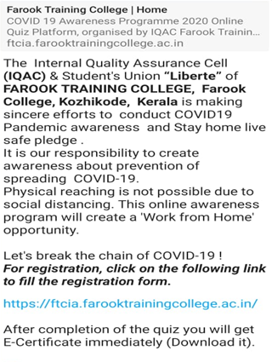
Report
Covid 19 Online Quiz & Awareness Programme
7th May – 21st May 2020

The Internal Quality Assurance Cell (IQAC)& Student's Union “Liberte” of FAROOK TRAINING COLLEGE, Farook College, Kozhikode, Kerala organized COVID19 Online quiz and Awareness Programme from 07-05-2020 to 21-05-2020, with a view to create strong awareness of the pandemic among the public all over India. The awareness programme was conducted online ensuring social distance among the participants and thus raising forth 'Stay home live safe' pledge . Dr. T. Muhammed Saleem, Principal, Farook Training College, inaugurated the Quiz programme through online by registering as the first participant.
A total of 2520 users across India were registered and participated in quiz programme. Almost 2500 users downloaded the e-certificate after successful completion.
Registration Link ; https://ftcia.farooktrainingcollege.ac.in/
Gallery
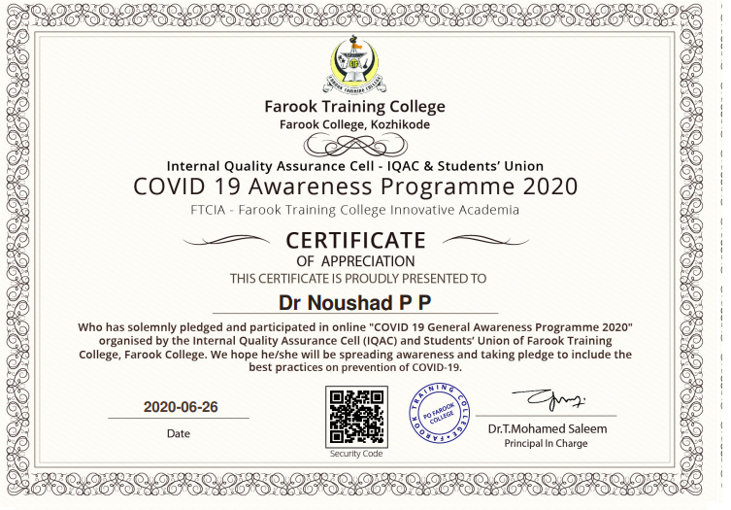
Appendices
Whatsapp Message
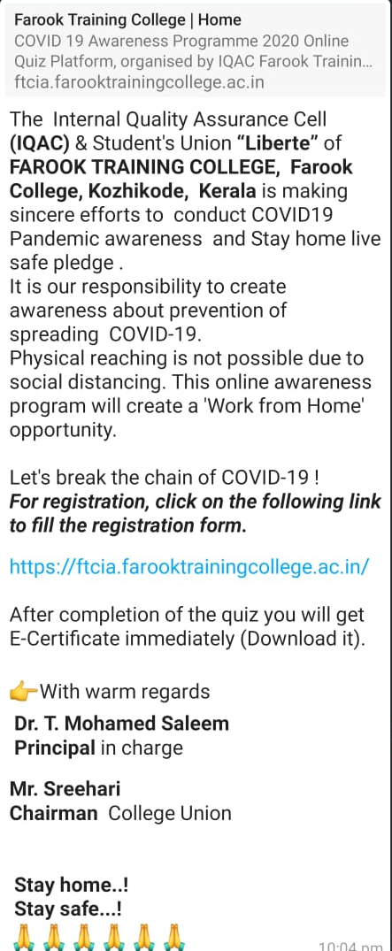

Certificates
To Download Certificate: https://drive.google.com/file/d/1Eh4jfRmx-Hvnn1Xc7I9OMp5Bs4Rm5pkK/view?usp=sharing
