Department Meeting 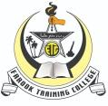 |Minutes of Meeting
Department Name : Extention Activity
Meeting date | time 8/22/2020 3:00 PM | Meeting location Online- G-Meet
Meeting called by Mr. Faseel Ahammed  Type of meeting Extension  Facilitator Dr. Umer Farooque T.K  Note taker Mr. Fasalul Abid CM  Timekeeper Mr. Sreehari | Attendees  Dr.T Muhammmed Saleem  Dr. Umer Farooque T.K  Dr. Afeef Tharavattath  Mr. Muhammed Sareef K  Mr. Noufal C

Meeting Agenda
Date 22/08/2020|Time allotted 30 mts|From 3.00pm To 3.30 pm| Presenter Mr. Faseel Ahammed

- To distribute books to the needs students of GLPS Karinkallai

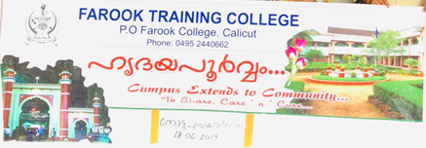

Report
Padanopakarana Vidaranam
Distribution of Learning Resources
27th August 2020

As part of the School Adoption Project of Farook Training College, learning resources were distributed to the students of GLPS Karinkkallai. College Principal Dr. T Muhammed Saleem inaugurated the distribution by handing over the materials to S.Manoj Kumar, HM In charge at GLPS Karinkkallai.
All the students from class 1 to 4 will receive kits including Notebooks, Workbooks, Drawing books and pencils. Mr .Fasalul Abid, Assistant Professor, Farook Training College was also present in the function.

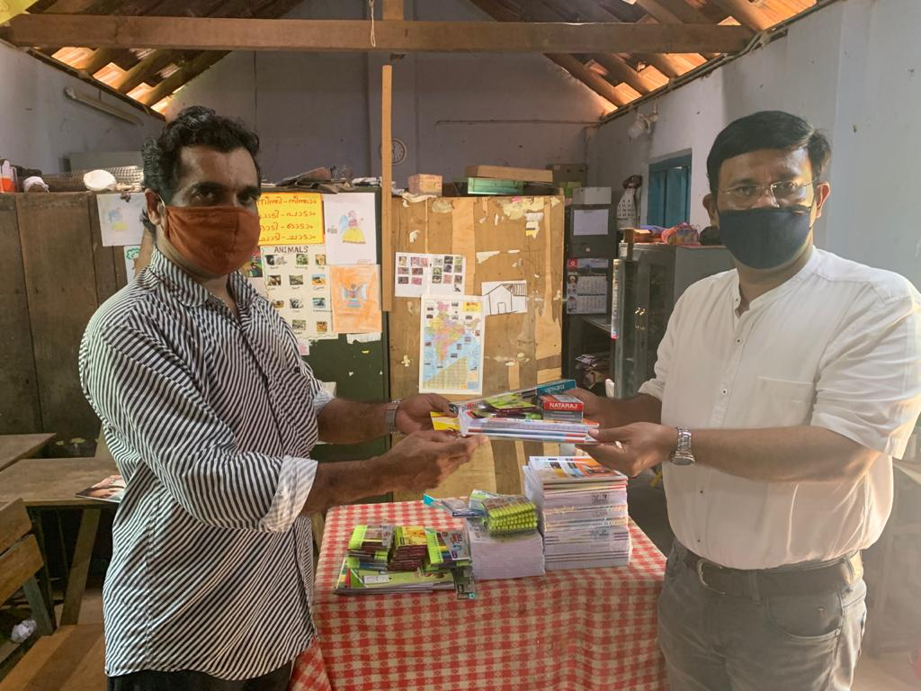

Gallery
