Department Meeting |Minutes of Meeting
Department Name : Extention Activity
Meeting date | time 12/22/2020 3:00 PM | Meeting location Online- G-Meet
Meeting called by Mr. Faseel Ahammed  Type of meeting Extension  Facilitator Dr. Manoj Praveen G  Note taker Mr. Fasalul Abid CM  Timekeeper Mr. Sreehari | Attendees  Dr.T Muhammmed Saleem  Dr. Aseel Abdul Wahid  Dr. Manoj Praveen G  Dr. Afeef Tharavattath  Mr. Muhammed Sareef K  Mr. Noufal C

Meeting Agenda
  - Date 22/12/2020|Time allotted 30 mts|From 3.00pm To 3.30 pm| Presenter Mr. Faseel Ahammed

- To start a Home Lab Project to nurture students interest in Science for the students of GLPS Karinkallai, an School Adoption Project of FTC on 31/12/2020

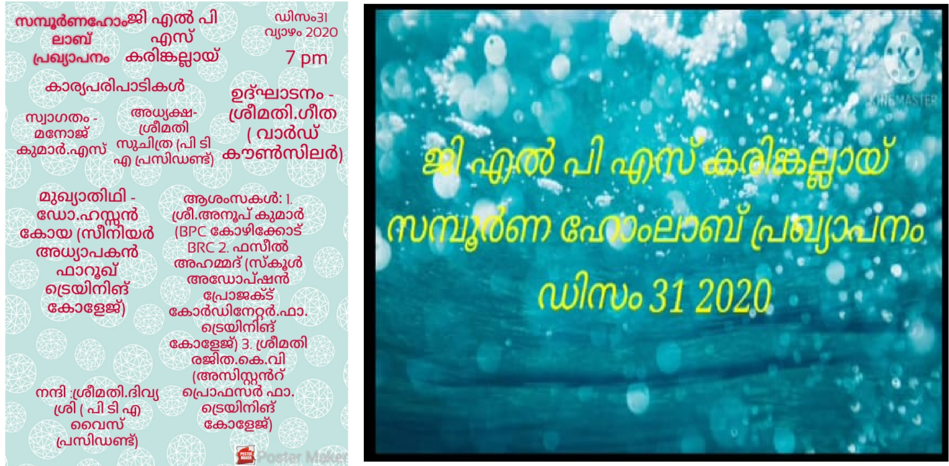
Report
Home Lab Project @ GLPS Karinkallai
31st December 2020

GLPS Karinkallai, the adopted school of Farook Training College, has started a home lab project to nurture students' interest in science. Ward Councilor Smt. Geetha inaugurated the project on 31.12.2020 and Dr. Mohammad Saleem, Principal, Farook Training College announced the support of Farook Training College in the venture. Dr. Hassankoya MP, Associate Professor, Farook Training College delivered the keynote address. Mr. Faseel Ahmed, Assistant Professor & School Adoption Project Coordinator, Farook Training College and Mrs. Rajitha KV, Assistant Professor, Farook Training College presented the felicitations.

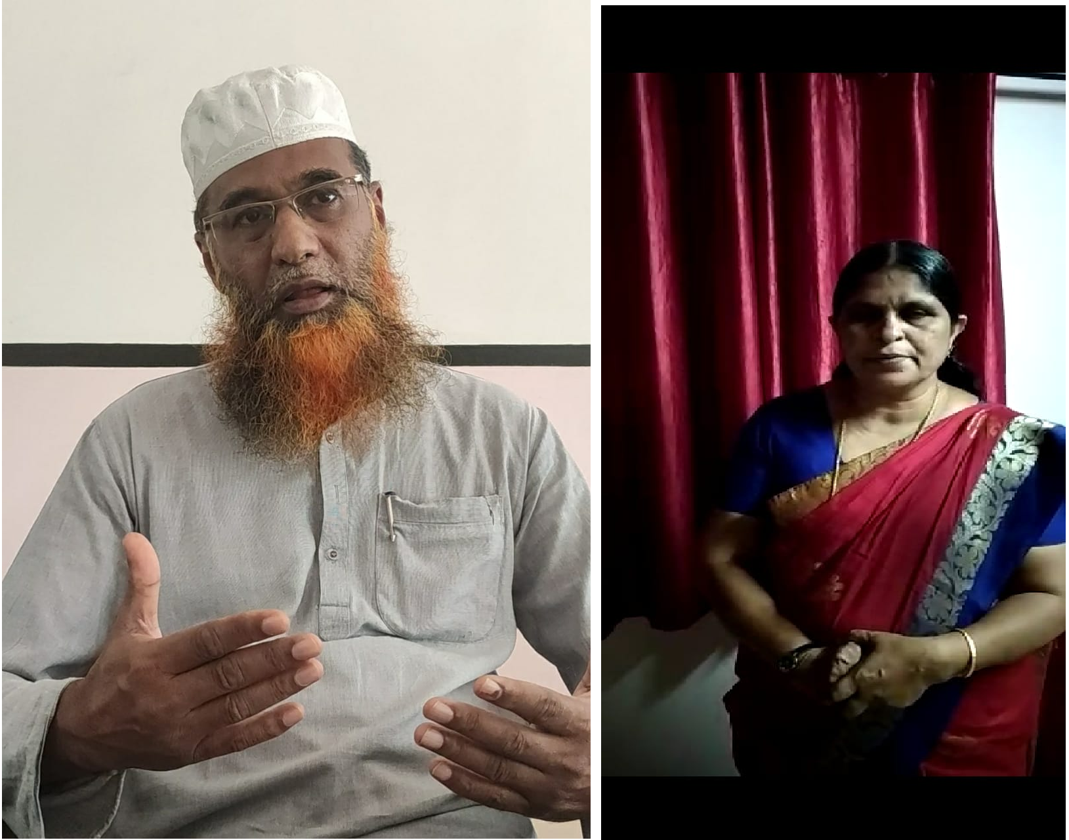

Gallery
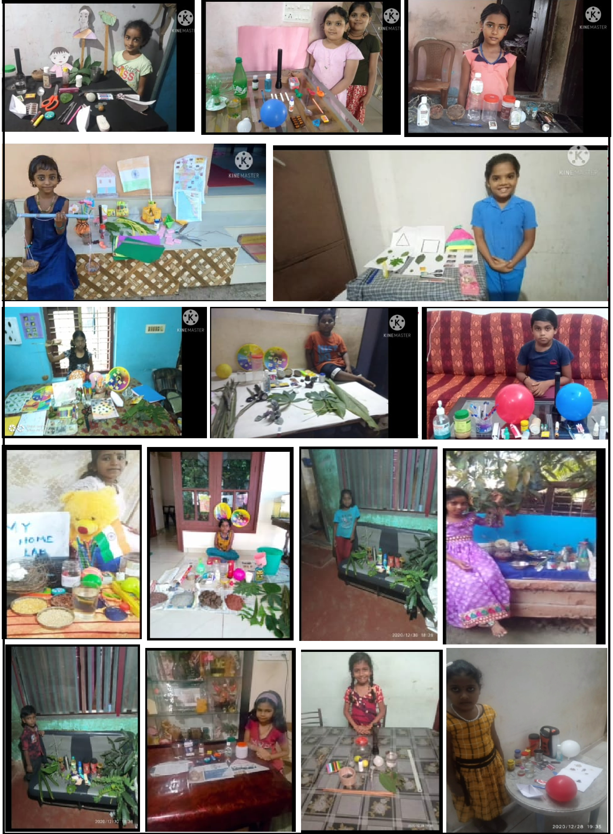
Prepared by Media Cell, FTC

