**Department Meeting 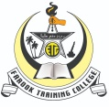 |Minutes of Meeting**

**Department Name : College Union & IQAC**

Meeting date | time 11/5/2020 7:00 PM | Meeting location *Online- G-Meet*

|  |  |  |  |  |  |  |  |  |  |  |  |  |  |  |
| --- | --- | --- | --- | --- | --- | --- | --- | --- | --- | --- | --- | --- | --- | --- |
| |  |  | | --- | --- | | **Meeting called by** | Mr. Noufal C | | **Type of meeting** | College Union & IQAC | | **Facilitator** | Dr.Manoj Praveen G | | **Note taker** | Mr.Sreehari R | | **Timekeeper** | Ms. Rajitha KV | |  |  | | |  | | --- | | **Attendees**  Dr. T Muhammed Saleem  Ms. Rajitha KV  Mr. Noufal C  Mr. Muhammed Sareef K  College Union Representatives  IQAC Members | |

# Meeting Agenda

**Date5**/11/2020**|Time allotted** 1**|From 7.00**pm To **8 pm| Presenter** Mr. Noufal C

* Farook Training College is organizing a book discussion on November 11 as part of the National Education Day celebrations. Dr. Shabeena Kuttay, a renowned educationist and professor, department of higher education, Jammu and kashmir, will inaugurate the event followed by a discussion on the book titled National Education Policy 2020- History, Perspective and Politics edited by KV Manoj and Siyas Mohammad. Mr Abbas Ali Principal, DIET ,Waynad will deliver the keynote address. The event will be live telecasted on the college's YouTube channel

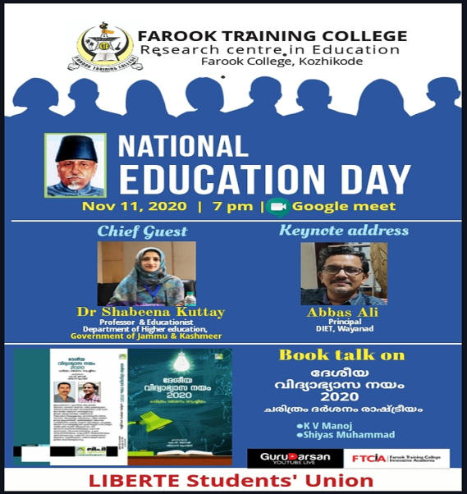

**Report**

**National Education Day**

***Webinar & Book Discussion***

11th November 2020

Farook Training College Liberte Students' Union organized a webinar followed by a book discussion as part of the National Education Day celebrations on November 11, the birthday of the first Education Minister of independent India. The event was inaugurated by Dr. Shabeena Kuttai, eminent thinker and Professor, Department of Higher Education, Jammu and Kashmir. In her short and eloquent inaugural address, she spoke about Azad's educational contributions. Dr. Mohammad Salim, the principal gave the introductory speech at the function which was presided over by Staff Advisor Nowfal C. Dr. TK Abbasali, principal, DIET Waynad delivered the keynote address. In his beautiful speech he explained why the National Education Policy has been widely criticized. It was followed by a discussion on a book titled National Education Policy 2020, History, Vision and Politics. Staff Secretary Mohammad Sharif led the discussion. KV Manoj, Shiyas Mohammad( Editors) and B.Ed student Ms. Shifanath took part in the informative and useful discussion. Union representative Ms. Fazila Kamal delivered welcome address and Ms. Binsha BS proposed vote of thanks. The G-meet event was live telecasted on the college YouTube channel Gurudarshanam

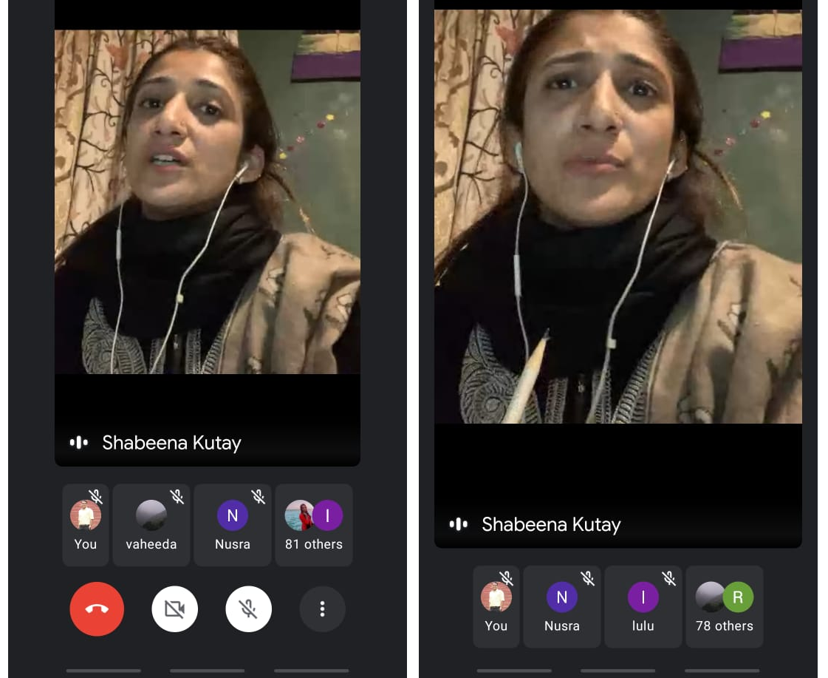

Book Discussion

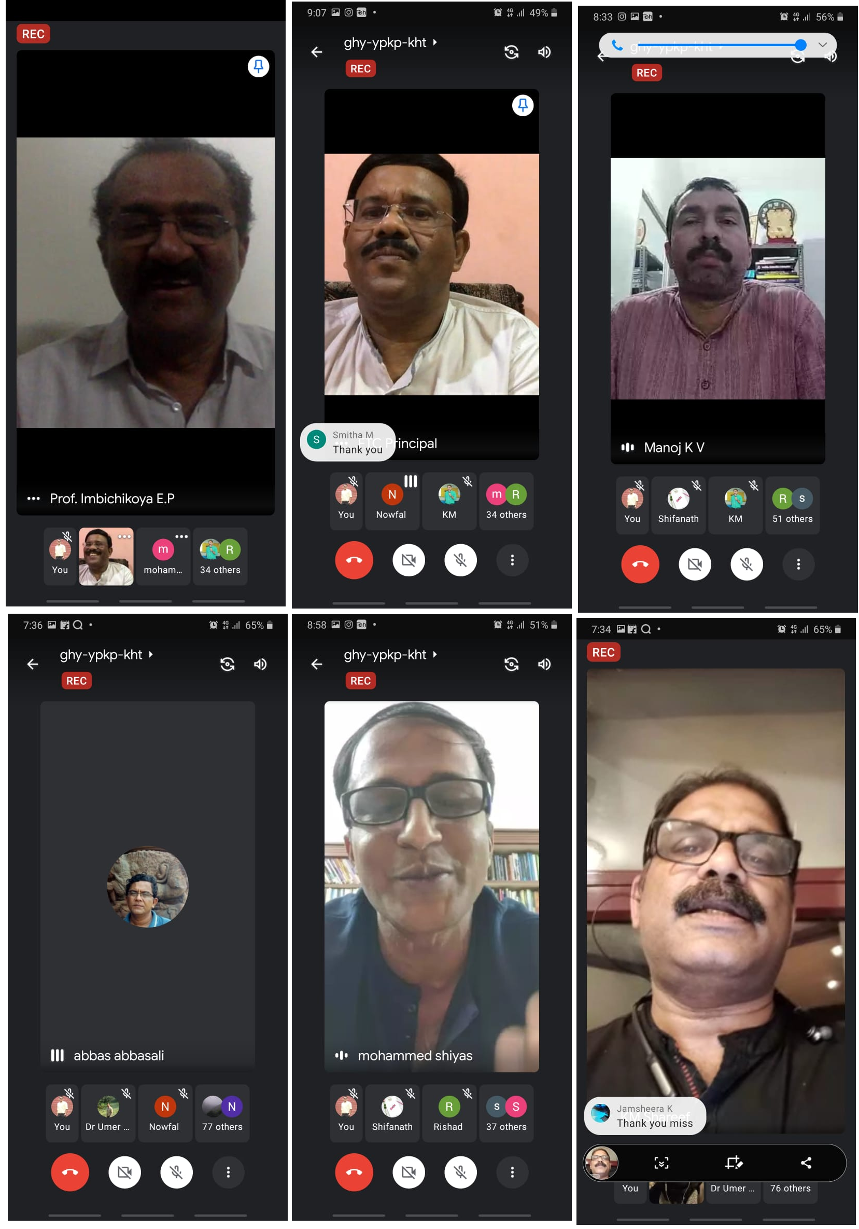

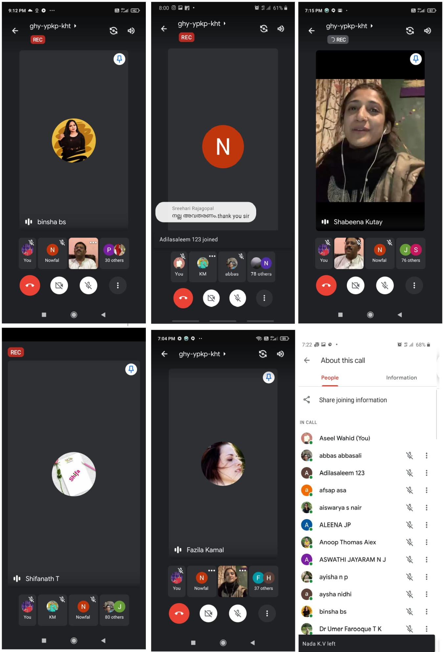

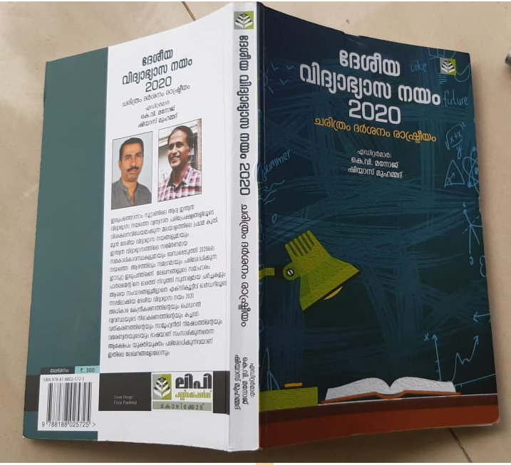

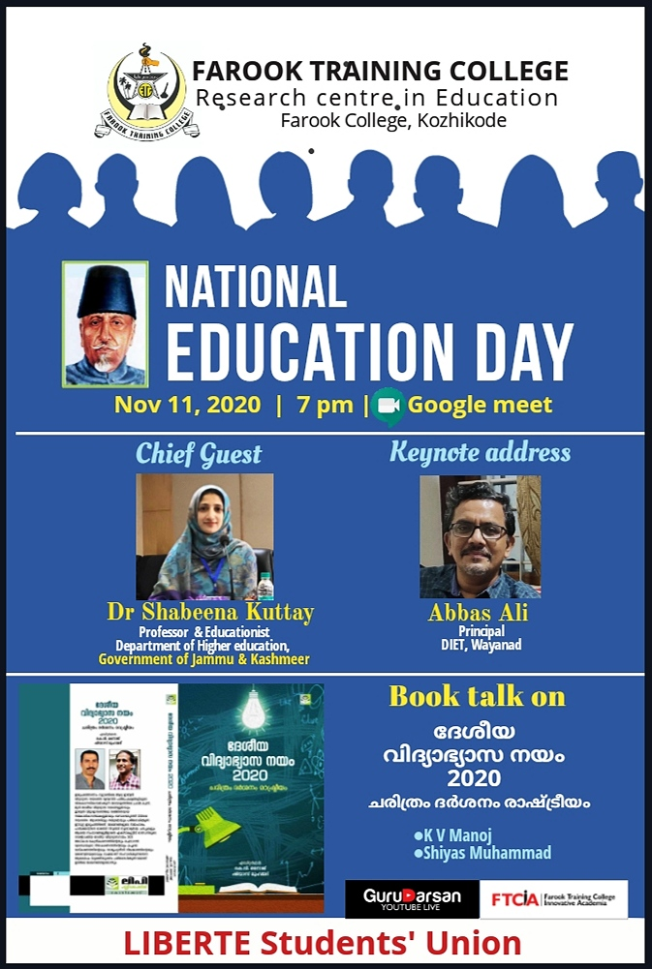

*Prepared by Media Cell, FTC*